RED RIVER
Quarter 4 SLA Report for January – March 2018

General background, aims and objectives

The aim is to work in partnership with the Friends of Red River community group to deliver an annual work programme, agreed with Heanor and Loscoe Town Council representatives, on the Red River Local Nature Reserve at Loscoe.

The intention is to improve the site for the benefit of the local community by ensuring public access, and to manage, maintain and develop the site to improve habitats and encourage bio-diversity of species. The Local Nature Reserve is home to a variety of both local and visiting wildlife. Regular wildlife recording visits will be made to record the changing wildlife throughout the seasons.

Additional funding will be sought to deliver a selection of environmental events, activities and guided walks to ensure ongoing public interest and involvement.
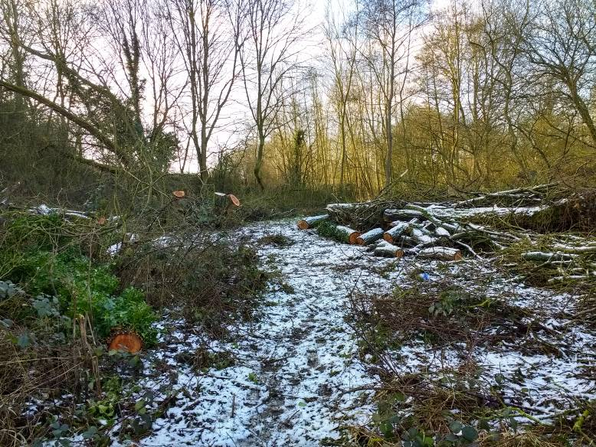

March saw a lot of snowfall.

Scenic view
Volunteer Practical Activities

During this quarter, there have been five Groundwork conservation volunteer days and two Friends of Group Saturday morning action days completed.
Over the three months, we have had 20.7 practical volunteer days completed by adults on the reserve and 17 different adults have been involved in volunteering on the reserve during this quarter. I have also visited the reserve with volunteers on three half days, one each month, to record the wildlife on the site. The severe snowy weather in March caused the cancellation of a FOG task day on Saturday 10th and a Conservation Volunteers task day on Monday 12th.

Summary of practical tasks in Quarter 4

- Regular litter picks on site to remove rubbish and recycle cans, bottles and plastic
- Cutting back of low and overhanging branches along the main path
- Clearance work of the encroaching vegetation along the main paths
- Clearing timber and brash from the willows felled by contractors
- Bonfire to burn accumulated brash and vegetation
- Constructing new dead hedges on site and improving existing dead hedging between meadow and woodland
- Tidy up of the area on left, just inside entrance gate to allow spring bulbs to be seen to their best advantage
- Remove bramble, hawthorn and willow to improve pond views from the path
- Clearing bramble and blackthorn from the Hazel coppice

Friends of Group (FOG) Task Days

The first action day of the quarter was postponed from Saturday 13th and held on Saturday 20th January. It was an overcast day with light showers from 11am. The five volunteers and I spent the whole morning sorting out the brash from the removal of the large willows. We built log piles, brash piles and a dead hedge to restrict access to part of the woodland. This area is starting to look really attractive now, although it is very damp due to the very wet weather. It will be interesting to see how it develops in the spring and what species of wildflowers start to come through.

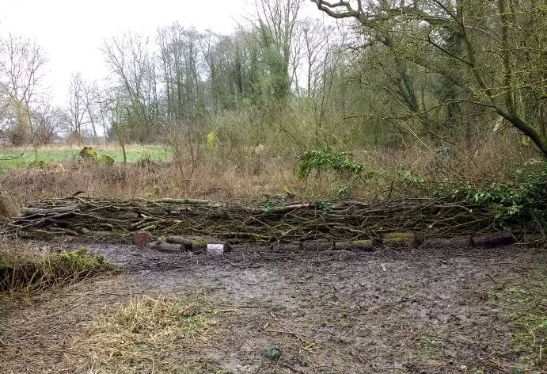
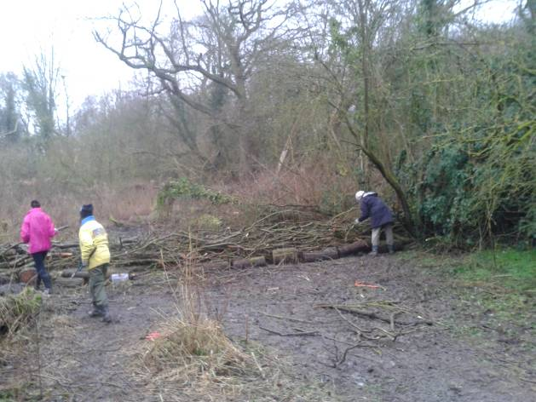

Building a dead hedge to restrict access to help preserve the woodland.

The February action day, held on Saturday 10th was a very cold day with light snow showers. Despite the weather, we had a great turn out of nine volunteers. We split into two teams, one team of six started to clear up the area to the left of the main entrance, removing fallen wood, clearing bramble and nettles and creating two separate habitat piles.
The clearance will allow the spring bulbs to prosper and the habitat piles will provide homes for mini-beasts, small mammals and possibly nesting places for our resident bird life.

The other three volunteers and I continued working on the wet woodland clearance (started on the January task). We also took out some smaller willows growing at an angle over the stream.
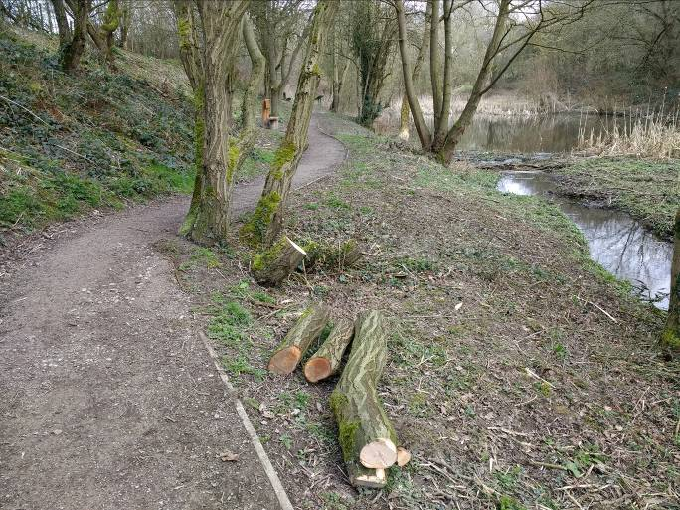
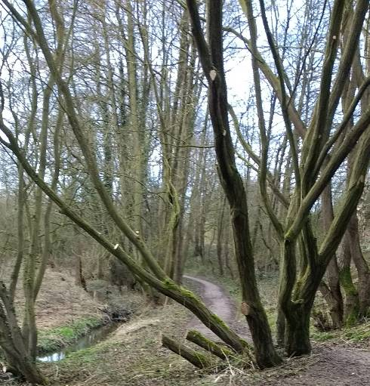
Clearing low willow branches to open up the view of the pond.

The March action day, due to be held on Saturday 10th, was cancelled due to the very wet weather and the poor ground conditions. The volunteers are enthusiastic and we often continue to work in the rain, but this was so bad, it was considered unsafe to go ahead with the task. Due to the various commitments of the group members it was not possible to re-schedule the task day during March.

Conservation Volunteer Tasks

Our first task of 2018 was held on Wednesday 17th January. The weather was awful, wet and cold with light snow showers followed by sleet. The two hardy volunteers and I continued working on clearing and stacking the brash and timber in the area where the large willows had been felled, just before Christmas. We took our lunch break, trying to get shelter under a large Blackthorn thicket, it was not very successful!!
It was heavy and cold work, so we finished early around 2.30pm.

The second task of the month, on Friday 26th, was spent on the same task, but we concentrated more on constructing structured habitat piles and adding additional material to the dead hedge, started by the FOG members the previous Saturday. At least the weather was a slight improvement, it was very cold and overcast, but we did occasionally have a few brief sunny spells, which were much appreciated.
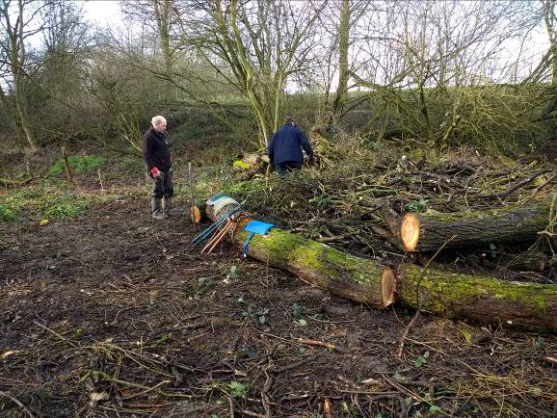
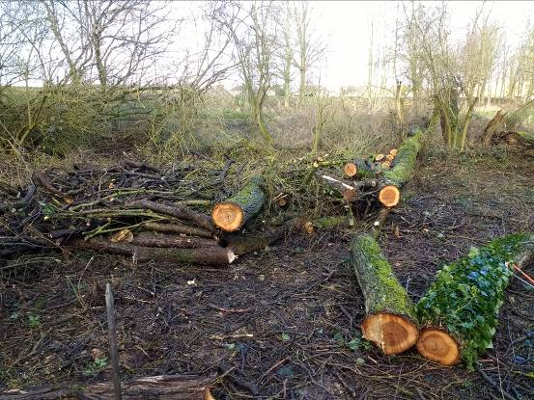
Large logs laid lengthwise to retain habitat pile and provide seating.

On our first visit in February, on Monday 12th, I was joined by five volunteers. The weather probably helped to encourage them to come along; it was a lovely sunny day but still very cold in the shade. I was pleased to welcome another new volunteer, Stephen who had seen our publicity and was keen to come along and help on a local nature reserve. We concentrated on cutting back vegetation along the main path. We trimmed some low branches around the benches to allow more light and head room. We cut down some more small willows growing at an angle over the stream and pond, which were starting to grow into the Alder trees along the stream edge. We also cut back the bramble and blackthorn to allow easier access and improve the views of the pond. We moved most of the vegetation further up the reserve to the bonfire site.

The second February visit was on Friday 23rd and it was overcast and cool but thankfully dry. I had another excellent turn out of six volunteers, three regulars, Stephen for his second visit which is encouraging, and two more new volunteers Jake and Peter. We concentrated on clearing the Hazel coppice bank of the bramble which was choking the young trees and using brash from previous tasks to thicken up the dead hedge between the wildflower meadow and the woodland.
A dead hedge is really good for controlling access around the reserve and also an excellent habitat for wildlife. We have had some very positive comments from passing members of the public about the dead hedging work.
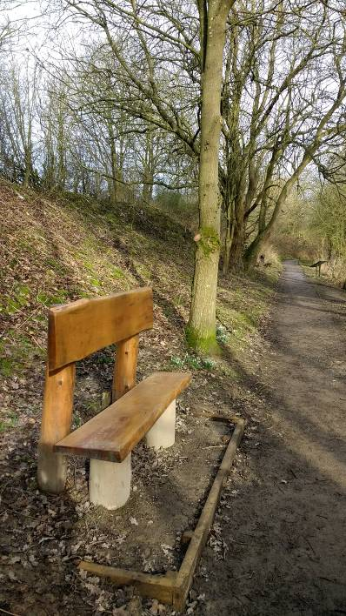
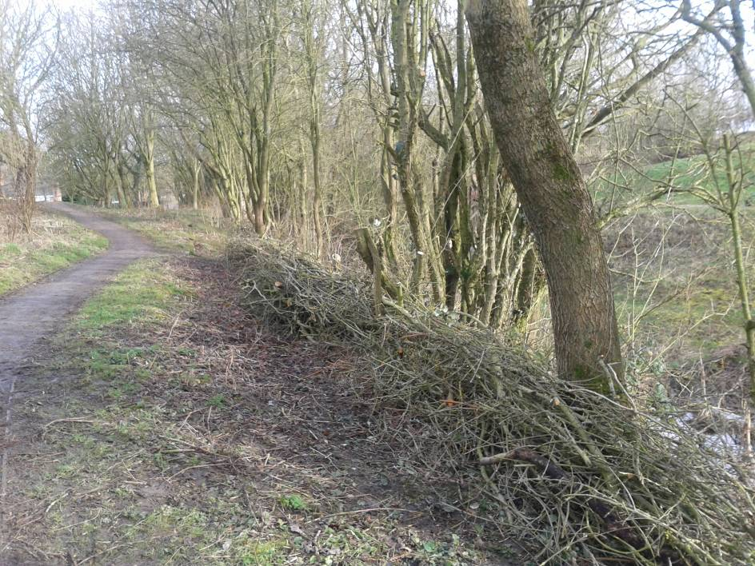
Bench platform edging boards, recently installed.

Dead hedges create habitat for a variety of creatures. Trees were pruned to improve the view of the pond.

Our first planned March visit was due on Monday 12th and despite torrential rain five, incredibly foolish, volunteers turned up. We decided to shelter in the van for 30 minutes to wait for the rain to ease, but if anything it got worse. After checking the forecast and looking at the site conditions I decided to call it off and offered lifts home to save them from getting totally soaked.
The second task day of March was on Wednesday 21st and the main planned task was a bonfire to burn up the accumulated brash. Three volunteers turned up on a dry but overcast day. The new volunteers had all sent their apologies. We got the bonfire going and David and Ben stayed with it, to continue to feed it with the brash. Claire and I completed the felling of the small overhanging willow trees and moved the brash to the bonfire and built a log pile with the timber. We also cleared a lot of small ash saplings from alongside the main path. It was a longish session, because we had to wait for the bonfire to burn through and then ensure it was properly damped down.
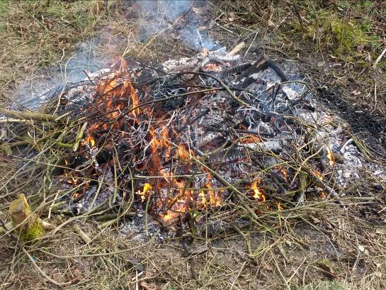
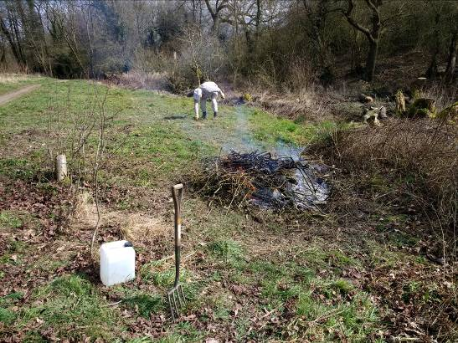

A selection of photos of the bonfire on March 21st.

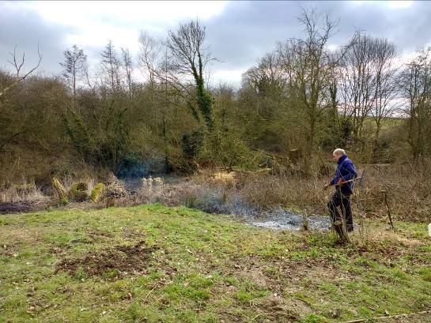
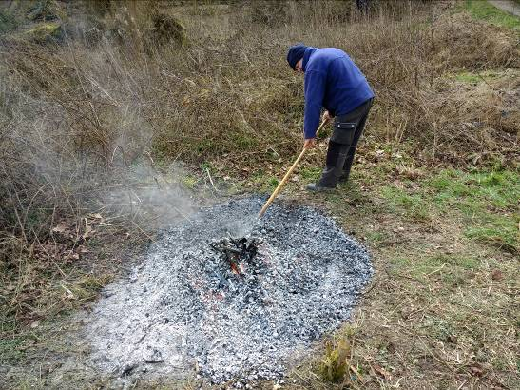

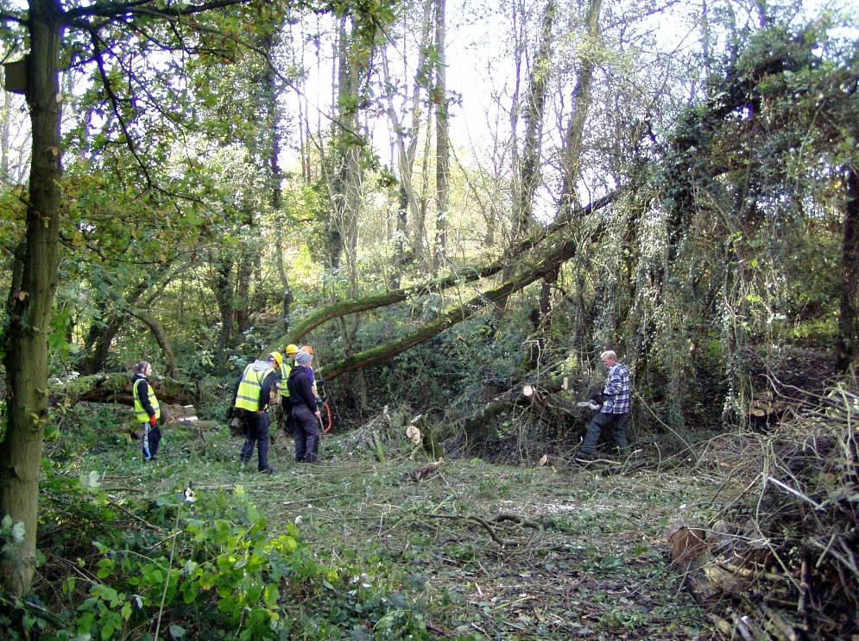
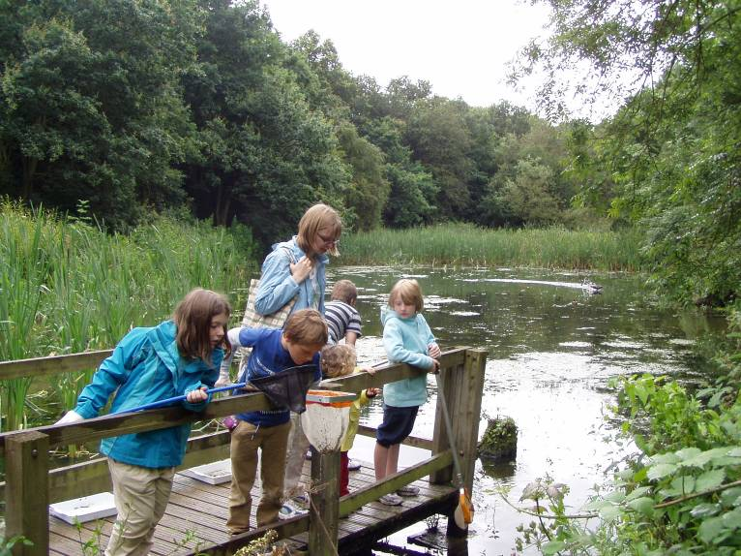
Meetings

There have been two Friends Of Group meeting this quarter, on Wednesday 10th January and Wednesday 7th March.

The January meeting was attended by seven members and was again held at the Tip Inn in Loscoe. The normal Chairman David was on holiday so I agreed to chair the meeting. It was a very busy meeting; we discussed the completed projects, the new logo, the Christmas banner, the willow tree felling and the very successful Christmas event. We made the decisions needed to move the new leaflet forward and brainstormed some projects for which we could seek grant funding. Sharon and I agreed some dates to meet to complete some funding bids. The publicity officer mentioned possible links with the Scouting Association in his report. We discussed the next three action days and made provisional plans for the tasks.

I had given my apologies in advance for the March meeting as I was on a short break in Norfolk to celebrate my birthday. I have currently not received the minutes of the meeting, so cannot yet report on the topics discussed.
Publicity

Publicity Officer
Alan continues to promote the group, and the volunteering opportunities, within the local area. His publicity cards are on display on the Red River Reserve and Town Council notice boards, and are regularly distributed to a number of shops locally. They are now on display at the Visitor Centre in Shipley Country Park, Heanor Tesco store and Heanor Library. I am continuing to be contacted by people who have seen the leaflet and want more information. The number of volunteers has increased since the publicity started, with five new volunteers getting in touch this quarter and three attending task days.
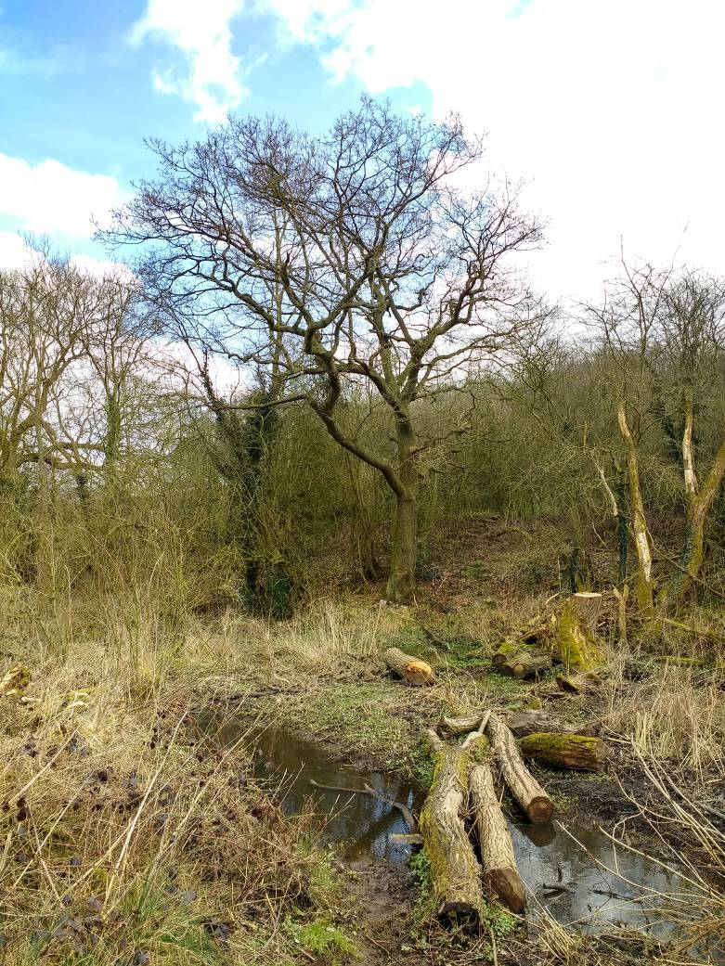
The willow removal improved the view of this splendid old oak tree.

Get Active! Help Nature Leaflet
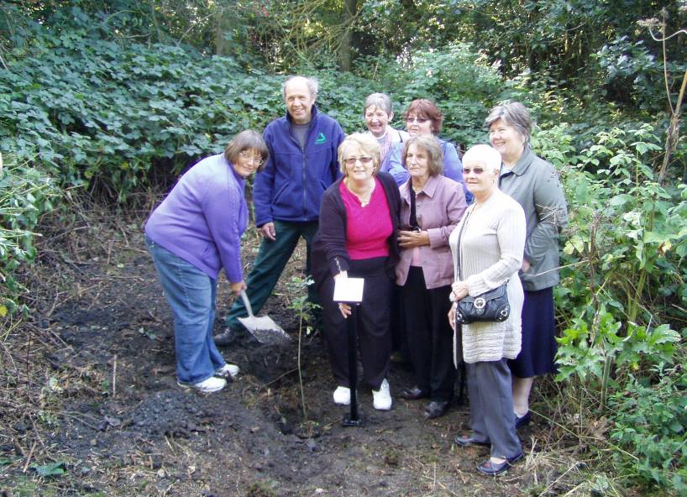
The Nature Reserve continues to be publicised in the Groundwork general leaflet promoting the health benefits of volunteering in the local environment.
This leaflet is regularly distributed to a number of local outlets including Amber Valley CVS, local libraries, community centres and stores. The leaflet is still my most successful way of attracting new volunteers.

Practical Task Programme
All tasks and events at Red River LNR are promoted on my general task programme. The task programme is produced quarterly and distributed around all the Groundwork Conservation Volunteers working with me. It is also distributed to all members of the numerous Friends of Group who help on the other reserves, in both Amber Valley and the Derbyshire Dales.

Tasks and Events
Specific tasks and events are promoted by posters distributed locally, including the reserve notice board, the Tesco community board and the visitor centre at Shipley Country Park and local libraries.

Funding

The group and I continue to seek out funding opportunities to support our work on the reserve. I have met with Sharon, the FOG Secretary on three mornings this quarter to prepare bids to go to the Tesco Bags of Help fund and to the Derbyshire Community Foundation. We met in the Ripley office on Friday 12th January, Monday 29th January and Tuesday 20th February and spent the mornings writing the bids and getting the supporting information together.

The £840 from the Derbyshire County Council Members’ Community Leadership Scheme has been paid to the Friends of Red River group. The two days completed by AA tree surgeons to remove all the dangerous willows has cost £670. The remaining £170 has been allocated to help towards the cost of an expert guide for a guided walk/launch event during 2018.

I have just had an email from Sharon informing me that their bid to the Tesco Bags of Help fund has been selected to go to a future public vote in five Tesco stores, including the store in Heanor. Please go along, collect your token and vote for this local project. We are guaranteed some funding, the amount depends on how many votes we collect as we are competing against two other local projects. I will let you know when the project is featured in the local store.

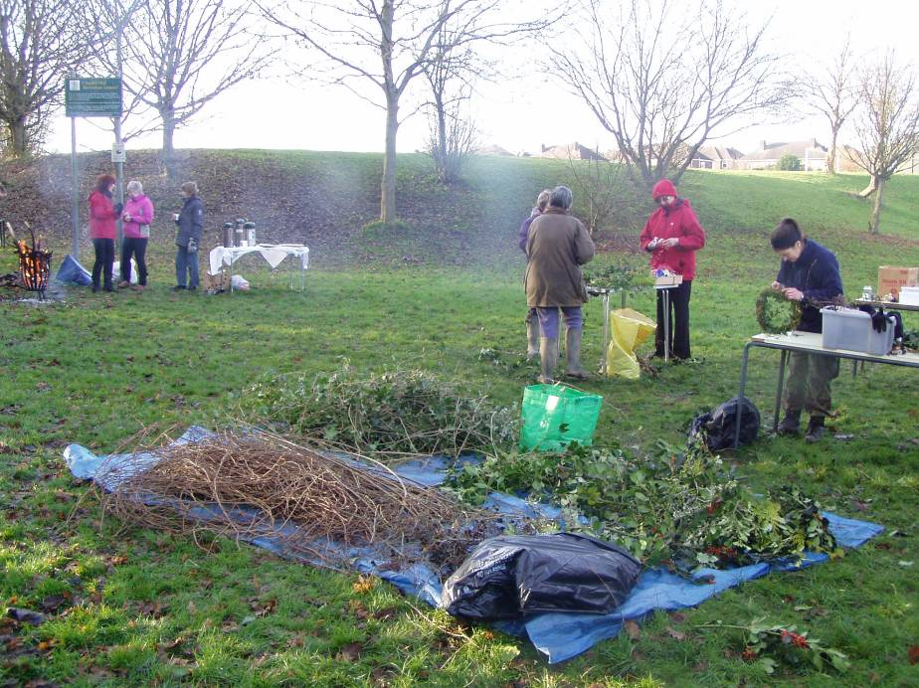
Statistics

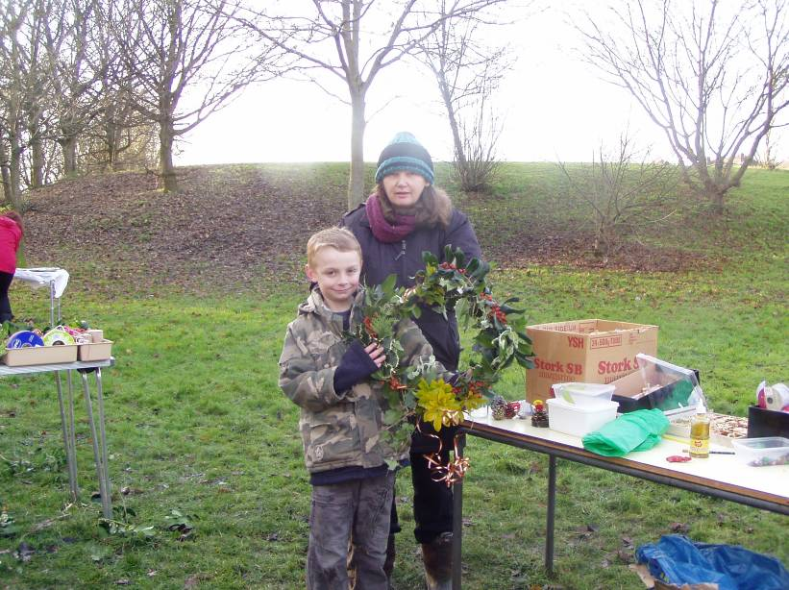
Summary Statistics - Quarter 4
No. of individual volunteers on practical tasks | 17
No. of individual volunteers on events | N/A
No. of individual volunteers on wildlife recording | 2
No. of Friends of Group meetings/action days attended | 2
No. of Practical volunteer days contributed by adult volunteers (124 hours divide by 6 hours) = | 20.7
No. of volunteer days contributed by volunteers on wildlife recording (18 hours divide by 6 hours) = | 3
No. of practical volunteer days contributed by young people | 0
No of days on events contributed by volunteers | N/A
No. of adults attending events | N/A
No. of children attending events | N/A
No of activities/events/practical days delivered by GCAM | 5
No of wildlife recording visits delivered by GCAM | 3
No of additional days spent on site by extra Groundwork Staff | 0

Volunteer Information - Quarter 4

Male volunteers | 11
Female Volunteers | 6
Unemployed | 6
Employed | 6
Retired | 5
Students | 0
Registered Disabled / Health problem | 4
Under 18 | 0
Aged 18-25 | 0
Aged 26-40 | 5
Aged 41-65 | 9
Over 65 | 3

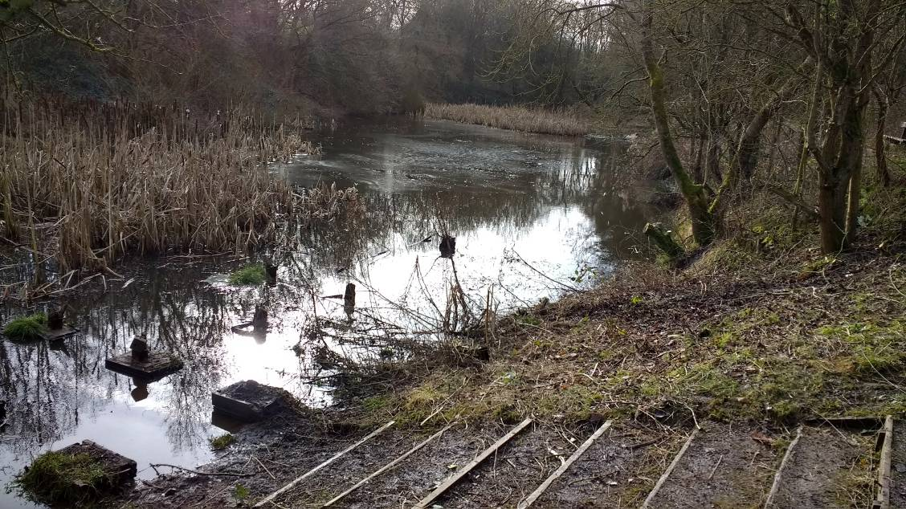
The remains of the old platform, hopefully soon to be replaced thanks to the successful Tesco bid.

Wildlife Recording

I look and listen out for wildlife on most of my visits to the reserve, but often I am too involved with the practical tasks and supervising the volunteers to, systematically, record everything seen or heard.
I am continuing the half-day wildlife recording visit to the reserve each month, to check and record our wildlife visitors, and to monitor the flora on the reserve.

I have spent two/three hours recording on the reserve each month this quarter; on Tuesday 16th January, Friday 16th February and Wednesday 21st March. These monthly recording visits help to build up a picture of what is likely to be seen during the year, and gives a more comprehensive idea of what wildlife is around on the reserve. These types of records become more valuable over time and help to monitor changing and improving habitats on the reserve.
Birds

The full list of 30 birds seen, or heard, this quarter include the following:
Jackdaw
Crow
Magpie
Jay
Blackbird
Mistle Thrush
Song Thrush

Great Tit
Blue Tit
Coal Tit
Long Tailed Tit
Mallard
Moorhen
Robin
Wren

Wood Pigeon
Green Woodpecker
B. H Gull
Starling
Dunnock
Grey Wagtail
Buzzard

Bullfinch
Chaffinch Goldfinch
Greenfinch
Nuthatch
Tree Creeper
Goldcrest Pheasant

Butterflies
The weather in January was reasonable but still too cold for any Butterfly sightings. February and March have had appalling weather and no butterflies have been seen this year so far. In normal years some butterflies are starting to put in an appearance by early March.

Monthly Records
The month by month summary is shown below:

January
Snowdrops were in flower on my visit on the 16th and may have been around for a few days. We spotted 17 species of bird on the visit including Long Tailed Tit, Goldcrest, Green Woodpecker, Jay, Buzzard and Tree Creeper which was probably the highlight. The task day on Saturday 20th provided us with an exceptional sighting, a Grey Wagtail feeding along the stream, a really unusual visitor.
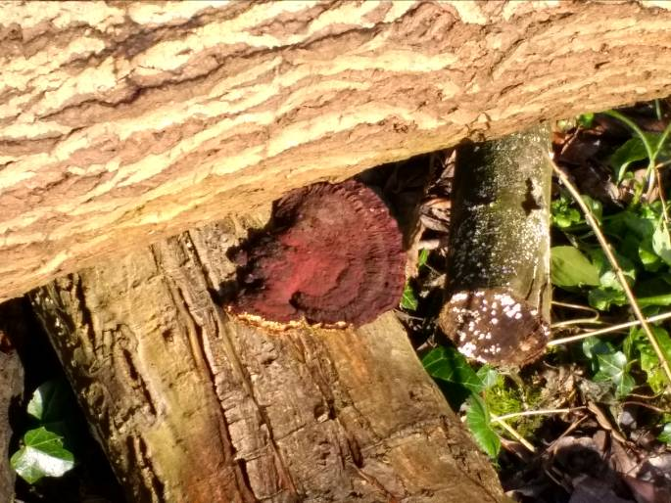
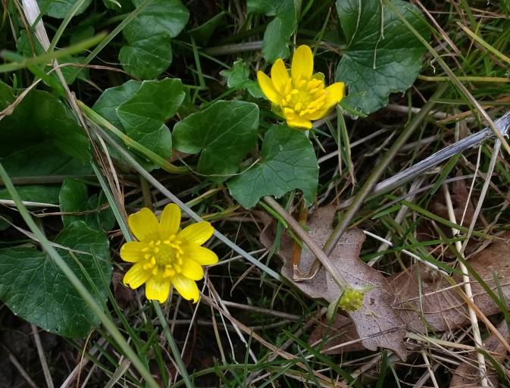

Bracket fungus
Lesser Celendines

February
By mid February, before the snows came, Snowdrops and Lesser Celandine were in flower, and there were lovely yellow catkins on the Hazel. The leaves of Daffodil, Primrose, Flag Iris, Dogs Mercury and Ramsons were starting to show. On the 16th Feb, we saw 17 bird species, the highlights being Nuthatch, two Tree Creepers, a pair of Bullfinch and Coal Tit There was also a very confiding Robin following us around, perhaps waiting for us to have lunch. Moorhens and Mallards were back on the pond.

March
On the, mid month, March wildlife visit, Daffodils, Primroses and Dogs Mercury were flowering and the Hazel catkins were still looking lovely despite the snow. The bird count this month produced 18, the best yet this year. We saw 5 Goldfinch, Mistle Thrush, Buzzard, Jackdaw and Bullfinch and heard Song Thrush and Greenfinch. We also saw a Pheasant close to the main path; we often hear it but very rarely see it. There is no sign of frog spawn in the pond yet; the cold weather has obviously put the frogs and toads off.
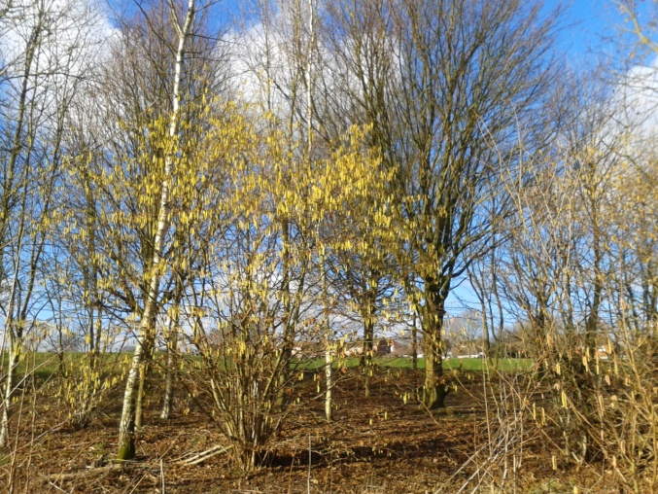
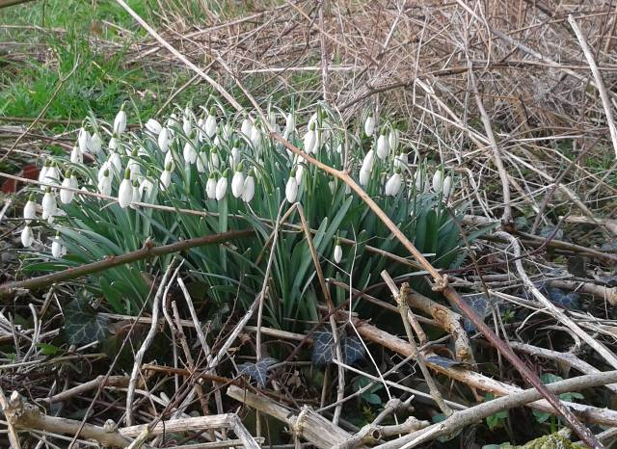

Hazel Catkins
Snowdrops

Future Tasks
During Quarter 1 (April to June 2018) the following meetings/practical days/events/activities are planned (please check with me before attending):-

April
Monday 16th Conservation Volunteers Task Day
Friday 27th Wildlife Recording Visit
Saturday 28th FOG Action Day

May
Wednesday 9th FOG AGM and Meeting
Saturday 12th FOG Action Day
Wednesday 16th Conservation Volunteers Task Day
Wednesday 23rd Conservation Volunteers Task Day
Wednesday 30th Wildlife Recording Visit

June
Saturday 9th FOG Action Day
Monday 11th Conservation Volunteers Task Day
Monday 25th Wildlife Recording Visit
Wednesday 27th Conservation Volunteers Task Day

