
RED RIVER LNR

Quarter 3 SLA Report for October – December 2018

General background, aims and objectives

The aim is to work in partnership with the Friends of Red River community group to deliver an annual work programme, agreed with Heanor and Loscoe Town Council representatives, on the Red River Local Nature Reserve at Loscoe.
The intention is to improve the site for the benefit of the local community by ensuring public access, and to manage, maintain and develop the site to improve habitats and encourage bio-diversity of species. The Local Nature Reserve is home to a variety of both local and visiting wildlife. Regular wildlife recording visits will be made to record the changing wildlife throughout the seasons.
Additional funding will be sought to deliver a selection of environmental events, activities and guided walks to ensure ongoing public interest and involvement.

Volunteer Practical Activities
Scenic view

During this quarter, there have been two Groundwork conservation volunteer days and three Friends of Group Saturday morning action days completed.
Over the three months, we have had 16.4 practical volunteer days completed by adults on the reserve and 17 different adults have been involved in volunteering on the reserve during this quarter.
I have also visited on three half days, one each month, to record the wildlife on the reserve. Three volunteers have helped with the wildlife recording volunteering for a total of 2 days

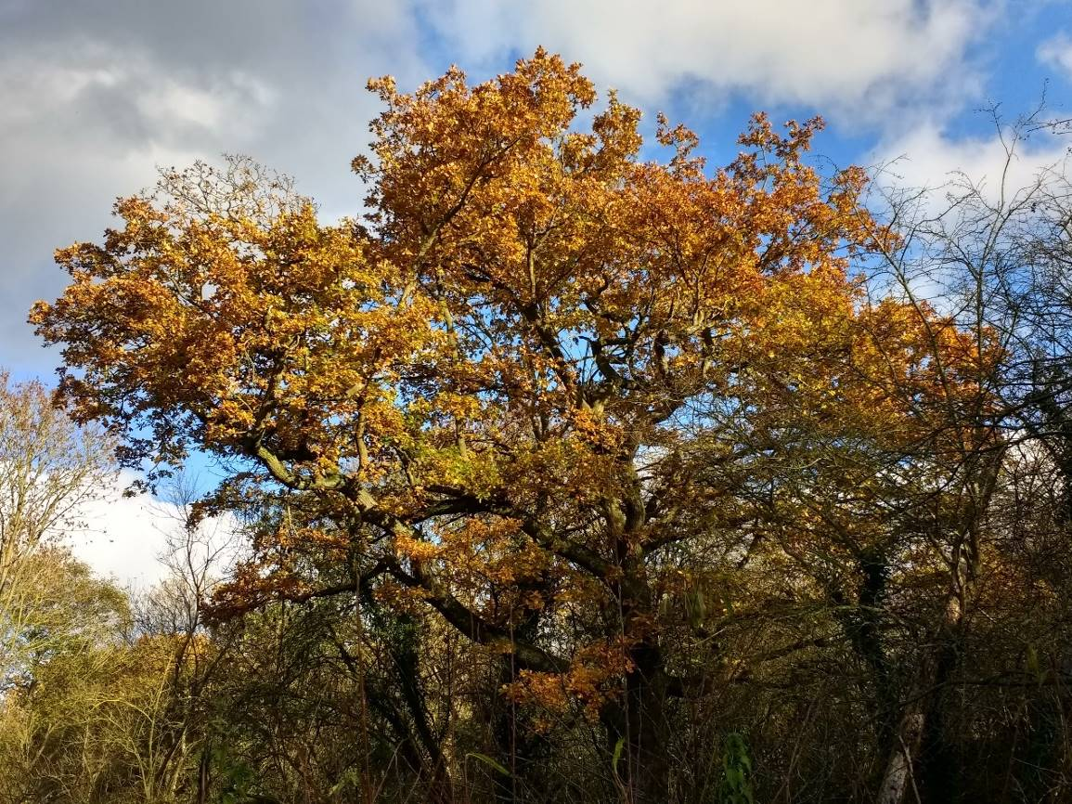

This beautiful oak tree, now revealed in all its splendour, after the removal of the dangerous willows.

Summary of practical tasks in Quarter 3

- Regular litter picks on site to remove rubbish and recycle cans, bottles and plastic
- Thicken up and reinforce the dead hedges on the reserve
- Cutting back of low and overhanging branches along the main path
- Cutting back of regenerating Willow in the newest woodland wildflower glade
- Cleaning Interpretation Panel
- Trimming of the hedgerows at and alongside the Reserve entrances.
- Removal of bramble and nettle roots from along the new woodland path and glade
- Thinning of the trees and removing scrub and bramble on the land between St Luke’s Church car park and the Red River reserve
- Cutting up and clearing timber and brash from the large fallen ash tree
- Removal of damaged bench and installation of the donated memorial bench
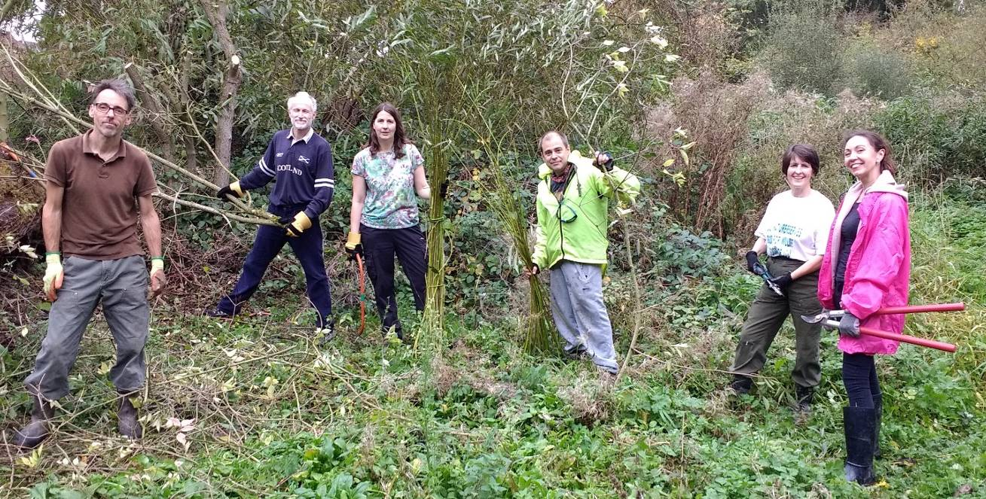

Keeping the new woodland glade clear.

Friends of Group (FOG) Task Days

The first action day this quarter was held on a warmish but overcast day on Saturday 13th October. It was led by my Groundwork colleague Marion Farrell, helped by 10 volunteers, a magnificent turn out for Marion. The two main tasks were clearing the large ash tree which had fallen just past the reed bed at the edge of the pond. The tree was cut up and the brash and timber relocated into the dead hedges and habitat piles around the reserve. The other main task was clearing the regenerating willow in the new woodland wildflower glade. A thorough litter pick was also carried out.

The second action day of the quarter, on Saturday 10th November, was the annual joint action day with the volunteers from St Luke’s Church. It was again an overcast but warm day and twelve volunteers from the group were present with three volunteers from the church increasing the numbers.
The main task of the day was thinning out the trees on the bank between the car park and the Red River reserve. We also removed the Leylandii conifers which were
looking quite unhealthy. We removed the accumulated brash and the rubbish it was hiding and cut back and dug out the bramble roots. We pruned back the large branches on the mature trees which were shading out the car park.
A smaller team worked in the church grounds, crown raising the small trees and shrubs and cutting back the ivy, which was beginning to swamp many plants and trees. The ivy would come in useful for the Christmas wreath event in early December.
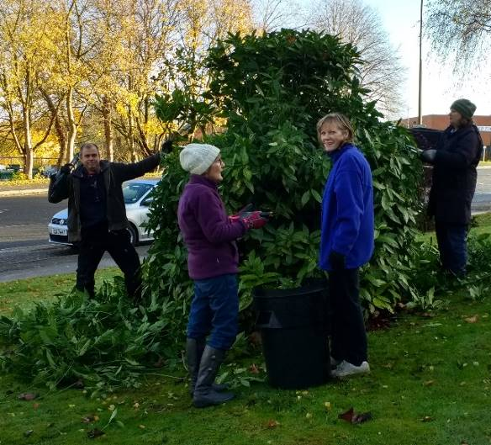
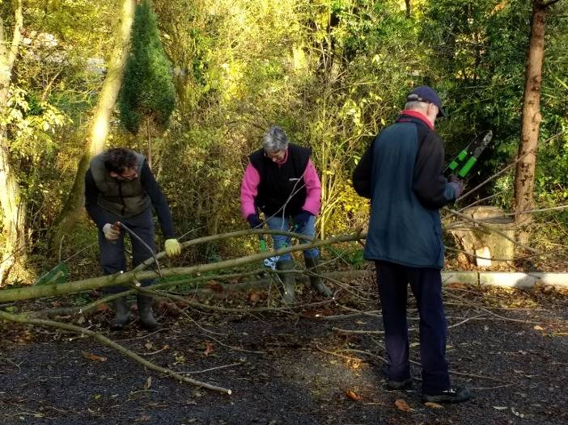

Our annual task day working with volunteers from St Luke’s Church.

The third action day of the quarter, on Saturday 8th December was another fine and dry morning and nine volunteers turned up. This was the morning of the Christmas Event and there was lots of preparation needed to be ready for the arrival of the public. Unfortunately, volunteer numbers were down due to Christmas activities, family commitments and illness.
The first task was to get the site and reserve ready, with a thorough litter pick and the horrible task of removing the dog pooh from on and around the event site. A small team were given the task of collecting the firewood for the Christmas fire and getting the brazier set up ready for lighting. A second team had the task of collecting additional vegetation, holly, ivy, willow and moss for the Christmas wreaths as we were expecting a good attendance. The main task involved setting up the gazeboes and the tables and laying out the materials to enable easy access and ensure adequate working space. The final task was to get the refreshments area ready, with the volunteers collecting the mulled wine, mulled fruit juice, mince pies, shortbread and other Christmas treats which they had prepared earlier. We were almost ready when, the first guests turned up early, as always, at just after 12.30.

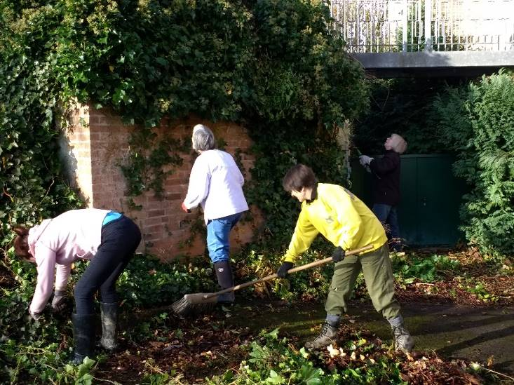
Gathering ivy and willow for the wreath making event.

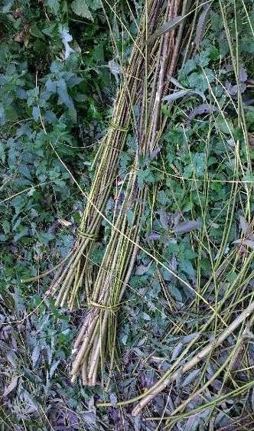

Conservation Volunteer Tasks

The scheduled task for October was postponed due to me getting a late Doctors appointment, as I had been feeling unwell for the last week. David and John still attended to meet with a contractor who was going to look at the site for the planned dipping platform and provide us with a quote for the work. The replacement date in October was cancelled due to heavy rain and strong winds.

The second scheduled visit of the quarter was on Monday 12th November and it was a dry, warm but overcast day with occasional showers later in the day. The planned task was the installation of the 1st World War memorial bench.
Marion, my Groundwork colleague, met my-self and a small team at the reserve, as we needed Marion’s van to transport the bench. We travelled up to the Town Council office to meet more volunteers and to collect and transfer the bench to the reserve for the scheduled start time of 9.15. The first task was to dismantle the damaged existing bench and transport the timber to the nearby waste amenity site. With five volunteers the bench installation went smoothly and unexpectedly quickly and allowed us enough time for an extra task; we cleared the vegetation in front of the bench to provide a lovely view of the pond. The cleared vegetation went onto the dead hedge alongside the main path.
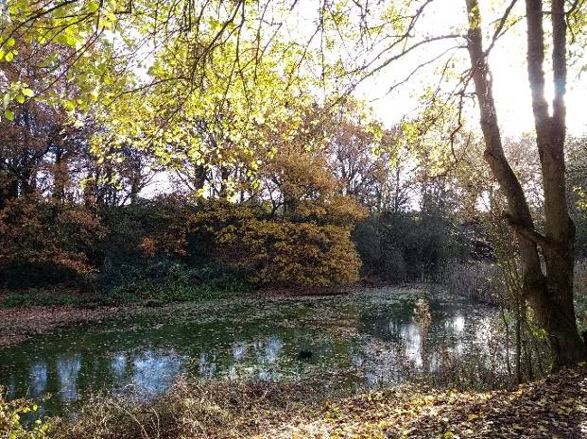
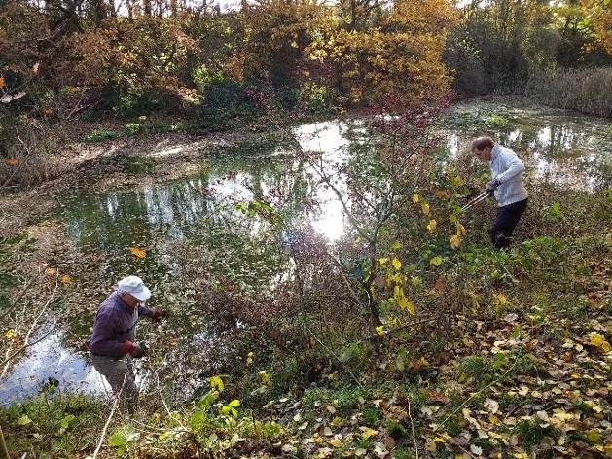
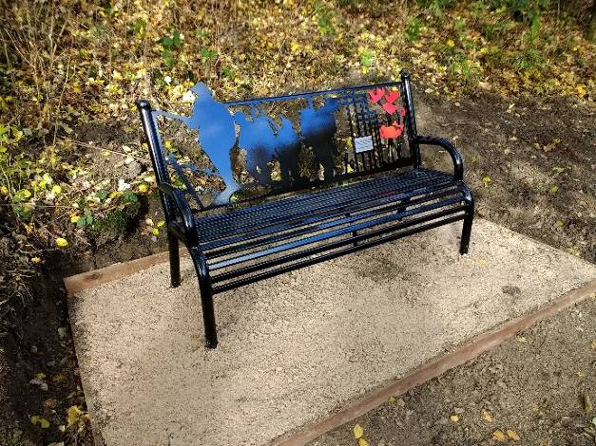
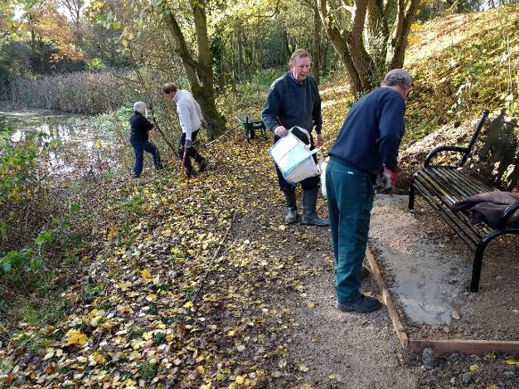
Installing the bench

Clearing vegetation to create a view

The new view from the bench.

The bench in place.

The final task of the quarter was originally planned for Monday 10th December but was brought forward to Wednesday 6th to allow us to collect all the materials needed for the Christmas event the following Saturday. A small team of three volunteers and I set out early to visit numerous sites to collect the natural materials. The willow was collected from alongside the pond at Duffield Millennium Meadows reserve, many thanks to the Duffield Millennium Meadows Conservation Trust. The holly with the permission of Amber Valley Borough Council was collected from the wonderful holly tree in Marlpool Cemetery and from a holly tree in a volunteer’s garden. The alder cones came from the trees alongside Osbornes Pond in Shipley Country Park, with permission of the park staff. Some of the ivy was also collected from Shipley Park to supplement the ivy collected, with permission, from St Luke’s Church and additional ivy from the Denefields reserve in Matlock, courtesy of Matlock Town Council. A visit to Matlock Forest provided us with the pine cones, which appeared to be in short supply this year. The dogwood was collected from volunteer’s gardens as was most of the moss, with additional moss collected from the lawn at St Luke’s Church.

A mid-afternoon finish to our scavenging trip, gave us the time to construct some willow rings which form the base for the Christmas wreaths. It was a very busy and tiring day, but important to ensure the smooth running of the Christmas event.
Events

The very popular, annual Christmas event was held at the reserve on Saturday 8th December, between 1 and 3 pm. The event, now in its seventh year is eagerly anticipated by the local community and for many people it is an important part of their Christmas social calendar.

The event is designed to give members of the public the opportunity to work with skilled, volunteer, environmental artist to produce attractive Christmas wreaths using natural materials. The wreaths are constructed using a woven willow circlet adorned with holly, ivy and other festive flora. The finished product is attractive, traditional, environmentally friendly and entirely biodegradable. Many of our visitors are now experienced wreath makers and newcomers to the event have many people willing to help them or offer advice.

Other Christmas decorations such as angels, stars and paper chains are available to make, and these are also popular. This year an additional activity was available, seasonal cards featuring a holly wreath or robin could be personally designed and decorated and this activity is popular with our younger visitors.
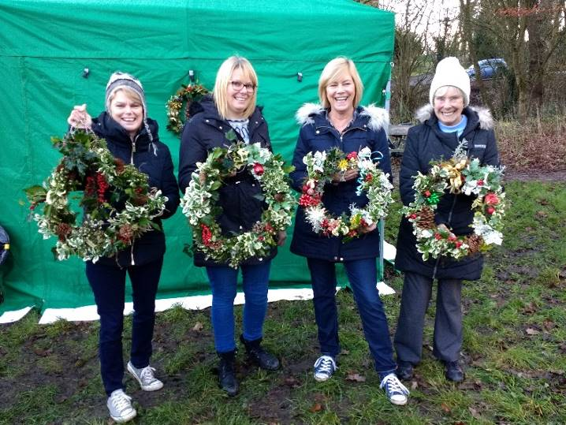
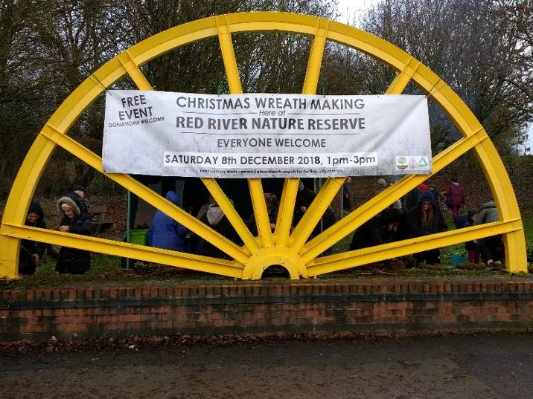
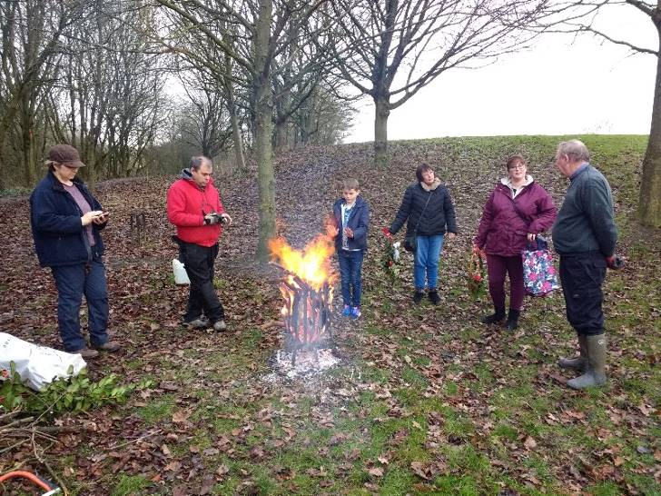

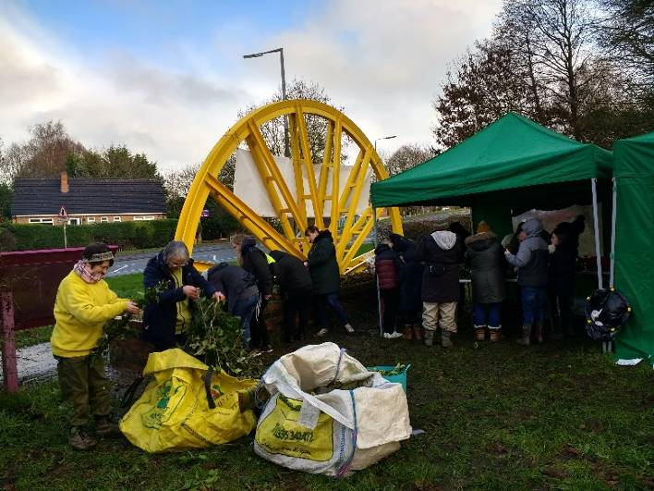

This year, we were not so lucky with the weather. The morning was fine and dry for getting set up but we had increasingly heavy showers throughout the afternoon. The two Gazeboes were invaluable in providing shelter from the heavy showers. The hot mulled wine and the brazier (burning locally-sourced wood) were most welcome and appreciated by the visitors. Refreshments are provided by the Friends of Group members and also included warm mulled soft drinks, mince pies, shortbread biscuits and Jaffa cakes.

Despite the poor afternoon weather, this year’s event attracted a total of 34 adults and 16 children and many outstanding wreaths and decorations were made and taken away. We had many people visiting for the first time this year, as they had seen our additional local publicity and our publicity on Facebook. An additional 10 volunteers helped to ensure that the event ran smoothly.

This year, again it was a very enjoyable event with a wonderful Christmas atmosphere. We received many favourable comments from both regular visitors and the many newcomers, who all agreed that they had a very enjoyable time, despite the very wet weather. Many local houses are likely to be decorated with a handsome Red River Wreath this Christmas, and we hope they will be once again next year.
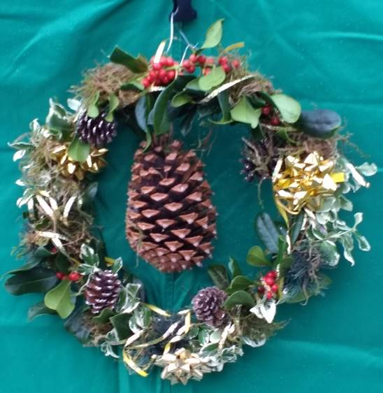
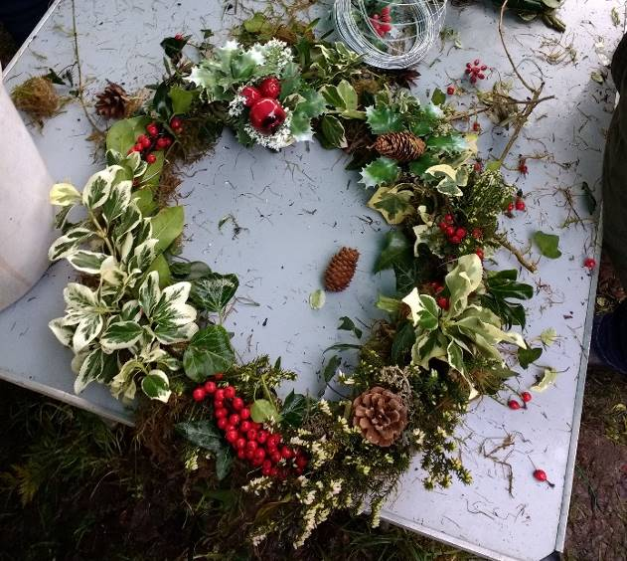

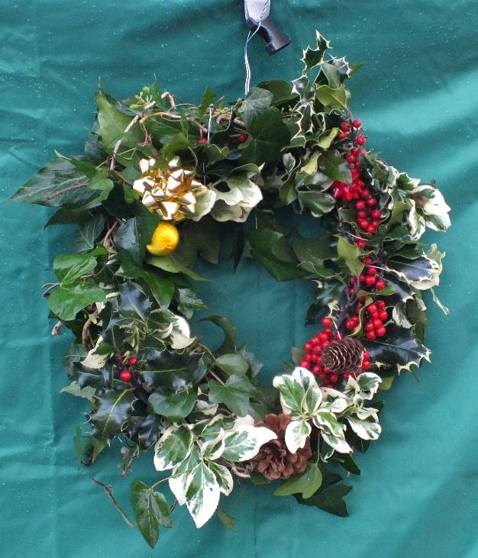

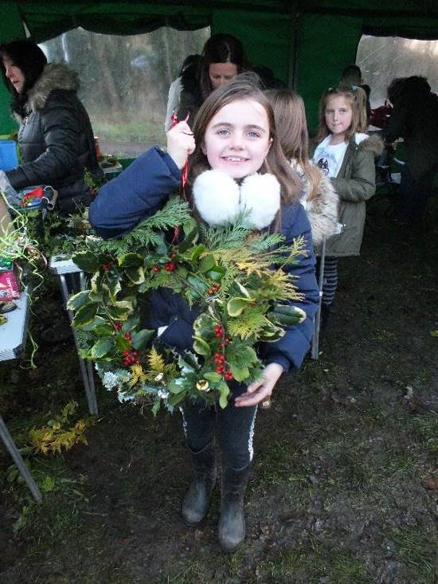

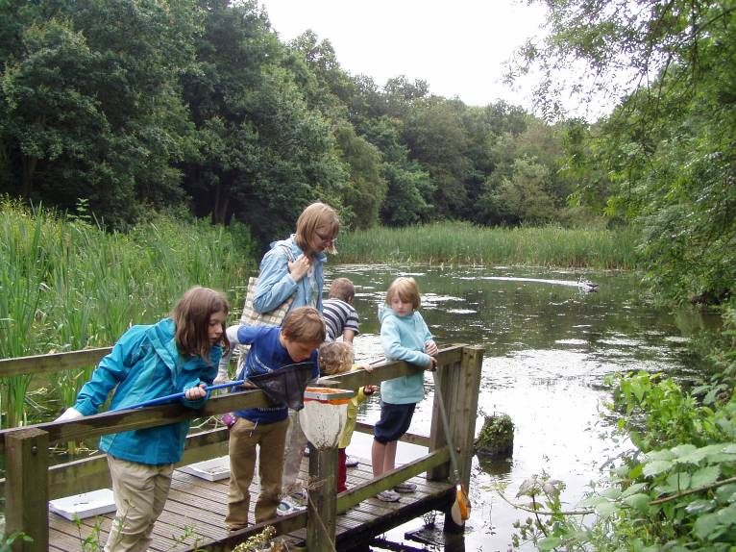
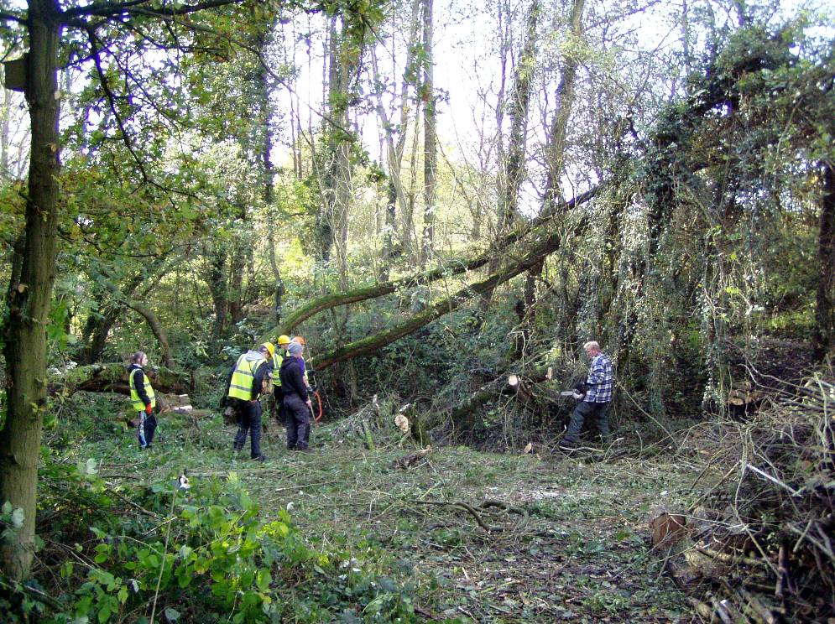
Meetings

There has been one Friends of Group meeting this quarter, on Wednesday 7th November, which was attended by seven members, with three apologies recorded. Items of discussion were the Red River logo, the planned new Red River leaflet, the proposed pond dipping platform and the preparations for the annual Christmas event on Saturday 8th December, which was the main topic of conversation. An action plan was agreed detailing responsibilities on the run up to the event and on the day itself.

Publicity

Publicity Officer
Alan is continuing to promote the group, and the volunteering opportunities, in the local area. Posters and cards are regularly distributed to a number of local outlets including Heanor Library, the local Tesco Store and Shipley Country Park Visitor Centre. Alan has recently concentrated on publicising the Christmas event visiting and distributing posters to many local outlets.

Get Active! Help Nature Leaflet
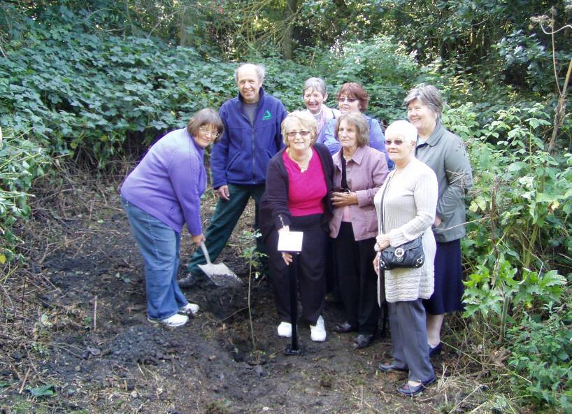
The Nature Reserve continues to be publicised in the Groundwork general leaflet promoting the health benefits of volunteering in the local environment.
The leaflet is distributed to a number of local outlets and organisations including Amber Valley CVS. I am often contacted by potential conservation volunteers, some of whom attend the Red River FOG task days.

Practical Task Programme
All tasks and events at Red River LNR are promoted on my general task programme. The task programme is produced quarterly and distributed around all the Groundwork Conservation Volunteers working with me. It is also distributed to all members of the numerous Friends of Group who help on the other reserves, in Amber Valley and the Derbyshire Dales. The January to March 2019 programme has just been emailed or posted to all my conservation volunteers.

Tasks and Events
Specific tasks and events are promoted by posters distributed locally, including the reserve notice board, the Tesco community board and the visitor centre at Shipley Country Park. Recently, to promote the Christmas event we displayed a large banner at the entrance to the reserve, fastened onto the winding wheel.

Funding

The group and I continue to seek out funding opportunities to support our work on the reserve.
A bid was submitted early this year to the Tesco Bags of Help scheme to secure funding to replace the Pond Dipping platform. As you know, the bid was selected nationally, to go forward to the public vote in the Derby area, which included the local Heanor store. It was voted on during May and June and we heard in August that we had been successful in winning the public vote, being awarded £4000 towards the Pond Dipping project.
We have recently received the quotes from contractors and have selected to work with Derwent Treescapes who submitted a quote £3650 + VAT. This means that the total cost exceeds the secured grant by £620. I have, with Laura’s assistance been successful in securing the £620 from Derbyshire County Council. I have been liaising with Sue Harrison of the Commissioning Communities and Policy Department who was able to offer the additional funding courtesy of Cllr Iliffe.

Groundwork is partnering Tesco in this Scheme and my role is to act as the community enabler for the Alfreton, Derby and Ilkeston areas. This means I promote and support bids within these Tesco areas, so I have to be one step removed from any bid submitted by the groups I assist.
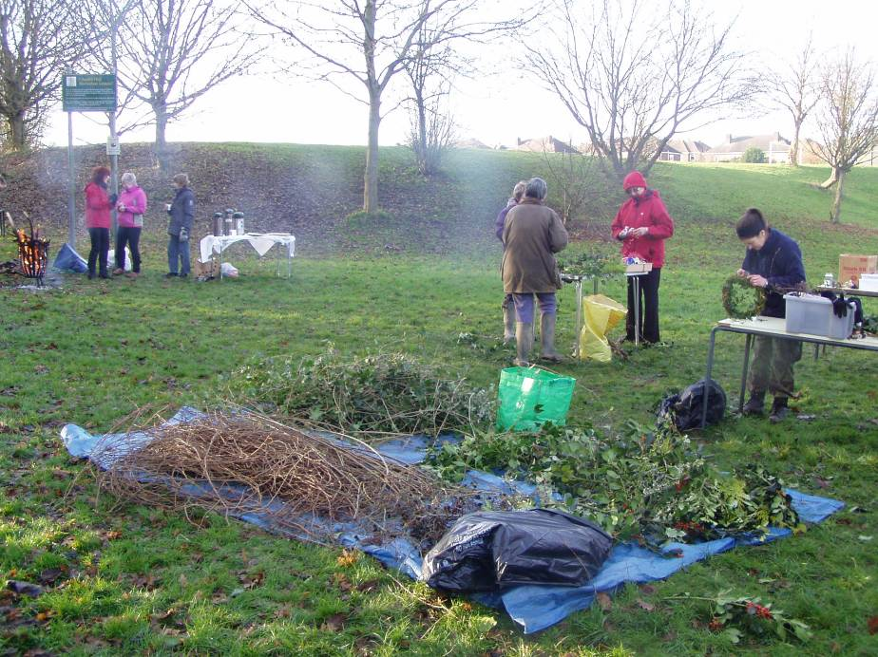
Statistics

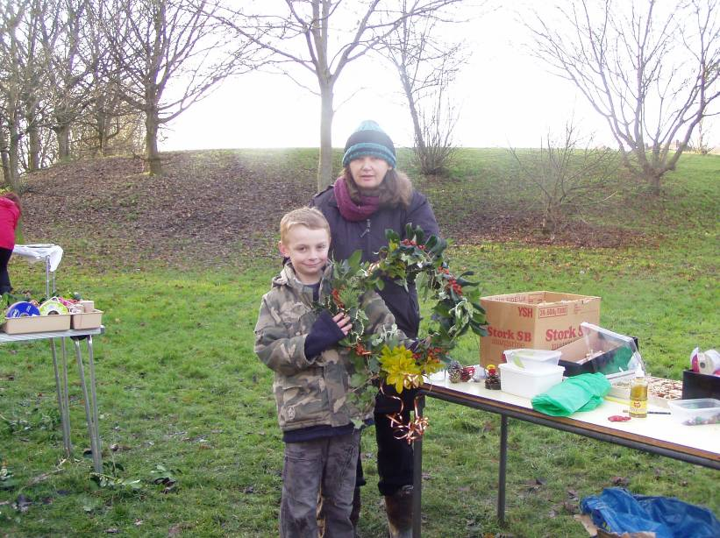
Summary Statistics - Quarter3
No. of individual volunteers on practical tasks | 17
No. of individual volunteers on events | 10
No. of individual volunteers on wildlife recording | 3
No. of Friends of Group meetings/action days attended | 3
No. of Practical volunteer days contributed by adult volunteers (98 hours divide by 6 hours) =16.4 | 16.4
No. of volunteer days contributed by volunteers on wildlife recording (12 hours divide by 6 hours) =2 | 2
No. of practical volunteer days contributed by young people | 0
No of days on events contributed by volunteers (58 hours divide by 6 hours) = 9.66 | 9.7
No. of adults attending events | 34
No. of children attending events | 16
No of activities/events/practical days delivered by GCAM | 5
No of wildlife recording visits delivered by GCAM | 3
No of additional days spent on site by extra Groundwork Staff | 1

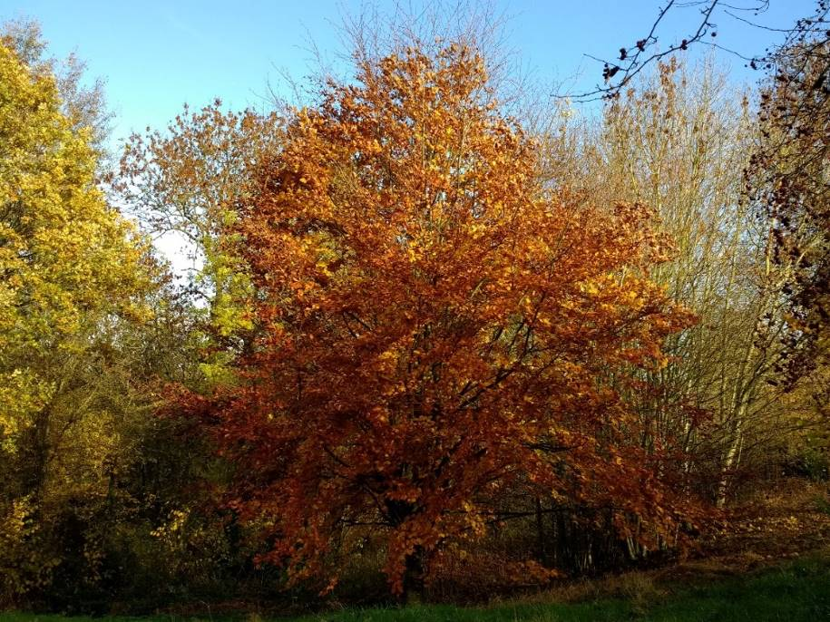
Beautiful Autumn colours on the meadow beech tree.

Volunteer Information - Quarter 3
Male volunteers | 8
Female Volunteers | 9
Unemployed | 3
Employed | 7
Retired | 7
Students | 0
Registered Disabled / Health problem | 5
Under 18 | 0
Aged 18-25 | 0
Aged 26-40 | 4
Aged 41-65 | 8
Over 65 | 5

Wildlife Recording

I look and listen out for wildlife on all of my visits to the reserve, but often I am too involved with the practical tasks and supervising the volunteers to, systematically, record everything seen or heard.
I am continuing with the half-day wildlife recording visits to the reserve each month, to check and record our wildlife visitors and observe the changes in the flora.

I have spent two/three hours recording on the reserve each month this quarter; Monday 15th October, Tuesday 16th November and Monday 10th December. I have been helped on these visits by three of our regular volunteers.
These monthly recording visits help to build up a picture of what is likely to be seen during the year and gives a more comprehensive idea of what wildlife is around on the reserve. These types of records become more valuable over time and help to monitor changing and improving habitats on the reserve.

Birds

This year we have spotted or heard a total of 24 species of bird. This quarter last year we recorded 31 different birds. The main difference is that the summer visitors had all left during September and, due to the mild weather, none of the winter visitors had arrived.
- Bullfinch
- Goldfinch
- Chaffinch
- Buzzard
- Dunnock
- Sparrow Hawk

- Wood Pigeon
- G. S. Woodpecker
- Song Thrush
- Blackbird
- Pied Wagtail
- Grey Wagtail

- Great Tit
- Blue Tit
- Long Tailed Tit
- Mallard
- Moorhen
- Robin

- Crow
- Magpie
- Jay
- Starling
- Nuthatch
- Wren

Butterflies

Butterfly sightings between October and December have included Red Admiral and Small Tortoiseshell.

Monthly Records
The month by month summary is shown below:

October
On the 15th October, we saw both Pied and Grey Wagtail. Other notable sightings included Jay, Nuthatch and two Buzzards over the reserve woodland. On Saturday 13th October we saw both Red Admiral and Small Tortoiseshell butterflies. Flowering plants included White Dead-Nettle, Wild Carrot, Red Campion, Bindweed and Hogweed. The Rowan trees and Hawthorns had plentiful supplies of colourful berries. There were wonderful displays of a variety of fungi this month. See pictures below.
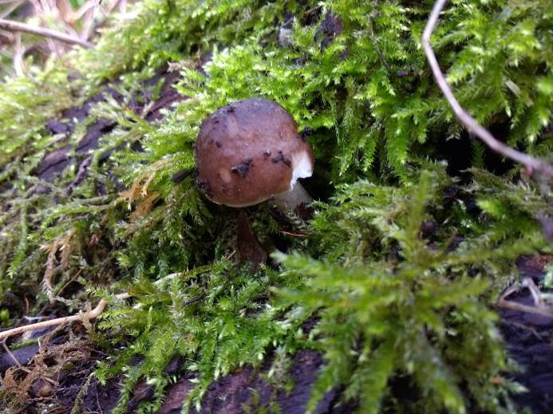
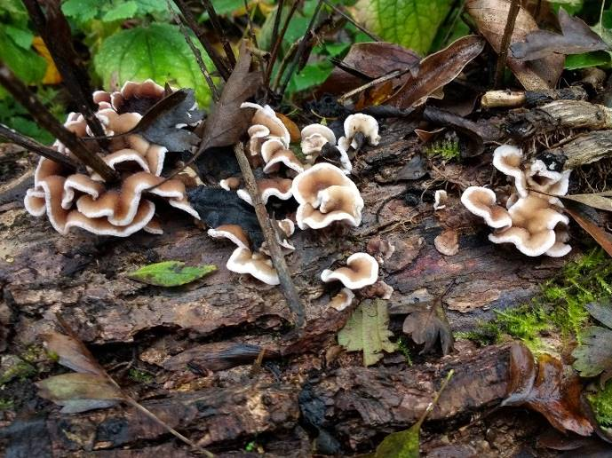

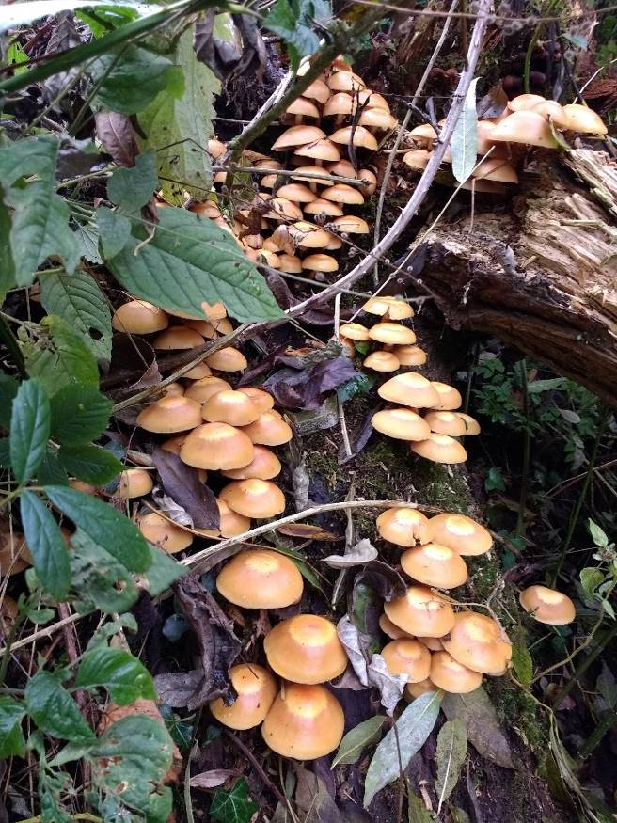
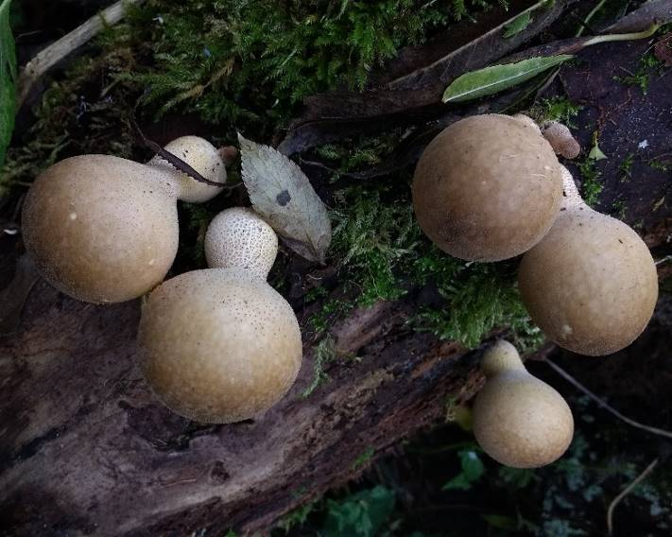

November
Sightings of Great Spotted Woodpecker and Sparrow Hawk were memorable on the 16th November, along with the more common Goldfinch, Blue Tit, Great Tit and Long Tailed Tit. Moorhens and Mallards were both back on the pond, now that the water has returned. A late Red Admiral butterfly was seen on Saturday 10th November. Grey Squirrels were also more obvious now that the trees have lost their leaves.

December
The visit on the 10th December recorded two Bullfinch, Song Thrush, Wren and the colourful Jay. Surprisingly, there have been no visiting Redwings or Fieldfares yet, possibly due to the unseasonal mild weather. There are plenty of sightings of Grey Squirrel now.

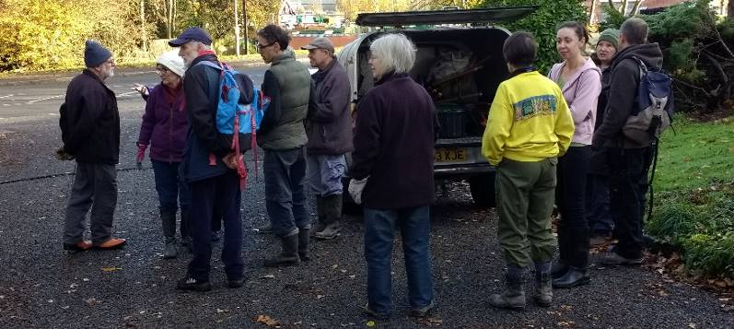
Future Tasks

During Quarter 4 (January to March 2019) the following meetings/practical days/events/activities are planned (please check with me before attending, as these dates may change):-
The team at morning briefing

Wednesday 9 January FOG Meeting
Saturday 12th January FOG Action Day
Monday 14th January Conservation Volunteers Task Day and Wildlife Recording

Saturday 9th February FOG Task Day
Monday 11th February Wildlife Recording Visit
Wednesday 13th February Conservation Volunteers Task Day
Friday 22nd February Conservation Volunteers Task Day

Wednesday 6th March FOG Meeting
Saturday 9th March Fog Action Day
Wednesday 13th March Conservation Volunteers Task Day
Tuesday 19th March Wildlife Recording Visit

