

**RED RIVER LNR**

**Quarter 2 SLA Report for July – September 2018**

**General background, aims and objectives**

The aim is to work in partnership with the Friends of Red River community group to deliver an annual work programme, agreed with Heanor and Loscoe Town Council representatives, on the Red River Local Nature Reserve at Loscoe.

The intention is to improve the site for the benefit of the local community by ensuring public access, and to manage, maintain and develop the site to improve habitats and encourage bio-diversity of species. The Local Nature Reserve is home to a variety of both local and visiting wildlife. Regular wildlife recording visits will be made to record the changing wildlife throughout the seasons.

Additional funding will be sought to deliver a selection of environmental events, activities and guided walks to ensure ongoing public interest and involvement.

**Volunteer Practical Activities**

Scenic view

During this quarter, there have been four Groundwork conservation volunteer days and three Friends of Group Saturday morning action days completed.

Over the three months, we have had 28.5 practical volunteer days completed by adults on the reserve and 15 different adults have been involved in volunteering on the reserve during this quarter.

I have also visited on three half days, one each month, to record the wildlife on the reserve. Four volunteers have helped with the wildlife recording volunteering for a total of 2.5 days

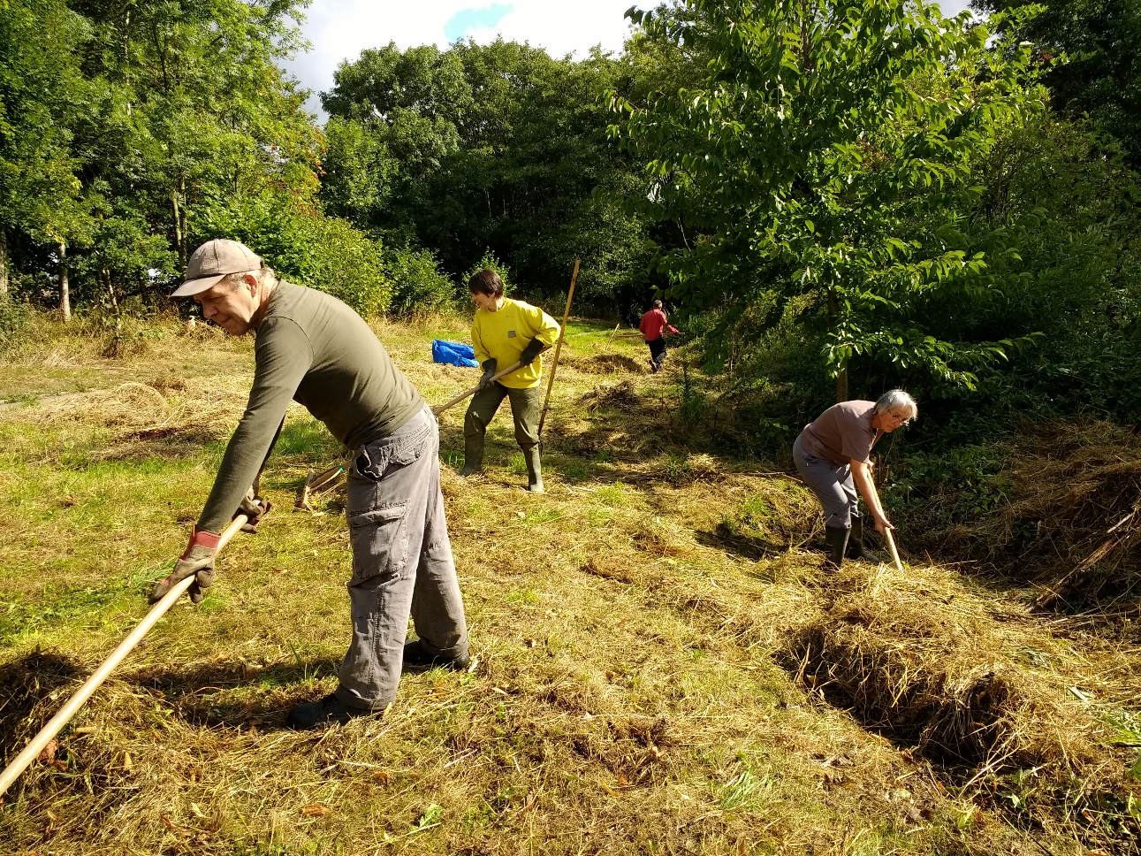

Hay making in the August sunshine.

**Summary of practical tasks in Quarter 2**

* Regular litter picks on site to remove rubbish and recycle cans, bottles and plastic
* Reed pulling in the pond, whilst water levels low or pond totally dry
* Mowing and scything the various wildflower meadows
* Thicken up and reinforce the dead hedges on the reserve
* Cutting back of low and overhanging branches along the main path
* Cutting back of regenerating Willow
* Removing remaining concrete bases from the old dipping platform
* Cleaning Interpretation panel and notice board
* Clearance work and strimming of the encroaching vegetation along the main paths.
* Trimming of the hedgerows at and alongside the Reserve entrances.
* Removal of bramble and nettle roots from along the new woodland path and glade
* Sowing Wildflower seed and Spring bulb planting
* Tidy up of the land between St Lukes Church car park and the Red River reserve

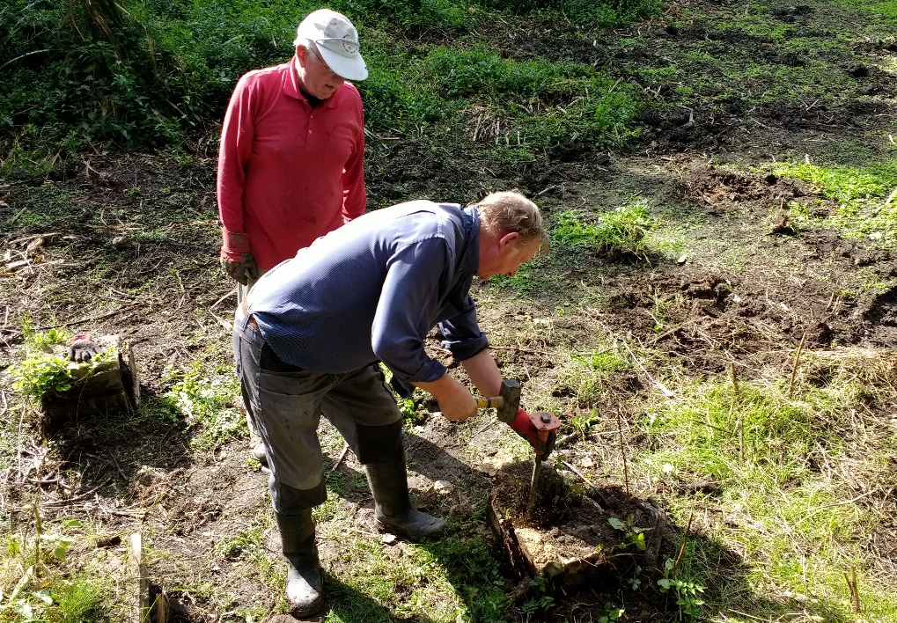

John and David remove the concrete base of the former dipping platform.



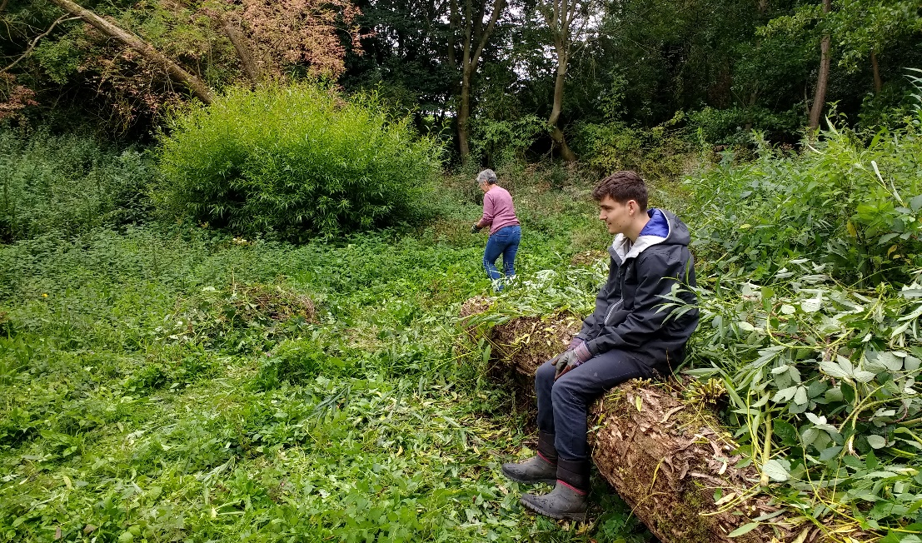

The new volunteers settle in well. Lynn works whilst Leam takes a break.

**Friends of Group (FOG) Task Days**

The first action day this quarter was scheduled for Saturday 14th July. It was postponed due to many volunteers being on holiday and was rescheduled for Saturday 4th August when a majority of volunteers were available again. It was a warm and sunny day, and as the pond was now dry, it was a perfect opportunity to commence the annual reed pulling task. The ten keen volunteers made large inroads into the clearance and all finished up very muddy.

The second action day of the quarter was moved from the 11th August to the 25th August, the final Saturday of the month. The wildflower meadows had been mown on Friday 17th and the Saturday task was to clear the grass from the wildflower meadows. It was another warm and dry day and eight volunteers turned out to help. I worked on raking up and moving the hay with the assistance of five volunteers. The other three went back into the dry pond to dig out and remove the remaining concrete bases from the former pond dipping platform. These were loaded into cars and taken across to the amenity tip.

The third action day of the quarter was another fine day and nine volunteers turned up on what, for a change, was the scheduled task day, Saturday 8th September. An encouraging sign was the attendance of two more new volunteers Lyn and Leam; the publicity is obviously still working. Celia took on the litter picking duties and the others split into two teams; Anne, Sharon, Peter and John continued the reed pulling task in the still dry pond. Ben, Chris and the new volunteers worked with me on spreading wildflower seed, bulb planting and cutting back the regenerating willow saplings in the newest glade.

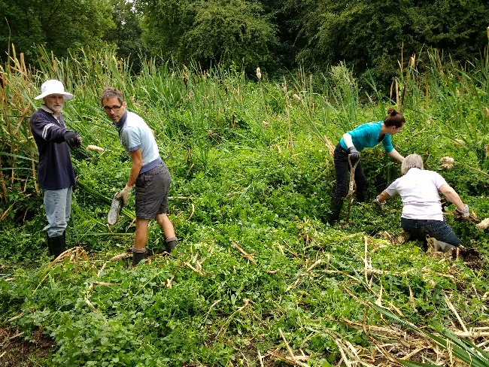

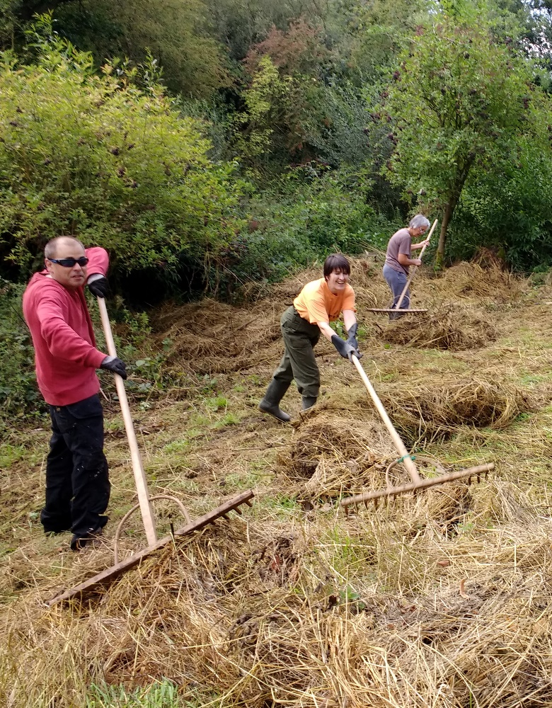

Reed pulling must be done annually to keep the pond clear.

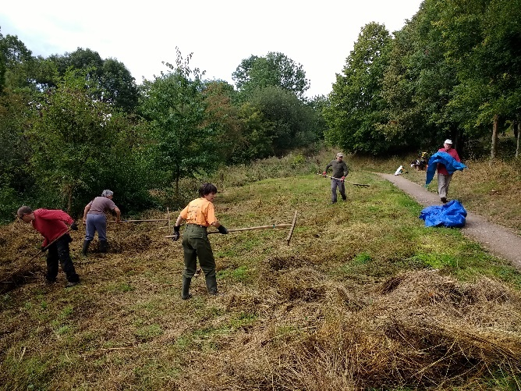

The annual grass raking at Red River, helped by the Friends of Group.

**Conservation Volunteer Tasks**

We visited the reserve once in **July** on Wednesday 25th. It was a very hot and sunny day and the five volunteers and I spent the morning in a dry pond, making a start on the reed pulling. In the afternoon it was too hot to stay in the direct sun, so we moved into the jubilee glade to cut the grass and trim the hedgerow; at least we got a bit of shade.

The second visit of the quarter was on Friday 17th **August** and it was a warm but overcast day with occasional sunny spells. The scheduled task was the mowing of the wildflower meadows and my Groundwork colleague Marion came along to help out with the machinery and trailer. We had additional help from four of the conservation volunteers and three volunteers from the Friends of group, a great turn out. I concentrated on strimming the coarser vegetation helped by Ben and Leam. Marion was in charge of the main wildflower meadow mowing using the reciprocating mower, helped by Claire and Chris. John, Anne and David were back in the pond on the never ending reed pulling task.

Three Volunteers and I were back on the reserve the following Friday, the 24th **August**. We were following up on the work undertaken by the St Lukes Church volunteers, who had felled a number of large trees on the land bordering the car park. In the morning we were moving the brash and incorporating it into the dead hedges along the car park boundary and around the lower wildflower meadow. We were also tidying up the fallen timber and creating log piles. This was warm work on a warm and sunny day, so in the afternoon we moved into the woodland on the edge of the pond, cutting back the regenerating willow poles, growing from the felled willows.

The final task of the quarter was on Wednesday 26th **September** and we undertook a wide variety of tasks. It was another fine dry day and four volunteers turned up to help. Alan mowed the path edges and the woodland path leading from the bridge into the new glade. Claire, Ben and Steve helped me with more willow pruning and sorting out a partly fallen tree over the main path near the recently repaired steps. In the afternoon we prepared the ground in the new glade and sowed patches of Yellow Rattle seed to help control the more vigorous grasses. (*Yellow Rattle lives by parasiting grasses, thereby reducing their strength and growth, creating better conditions for the more delicate wildflowers to thrive).* The final task of the day was moving the fallen reserve information panel and hiding it in the undergrowth, till we get enough people together to move it off site and see if it can be repaired.

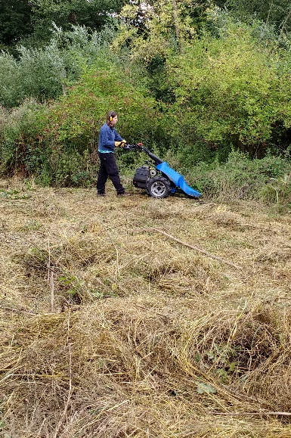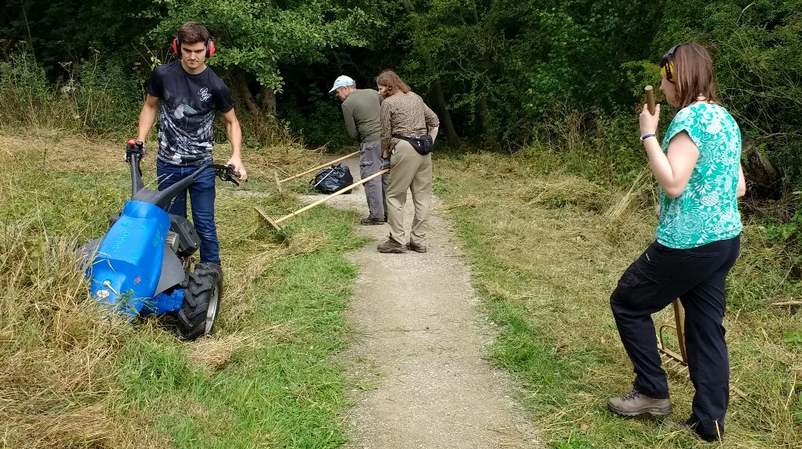

Mowing takes place every August to ensure a good wildflower meadow.

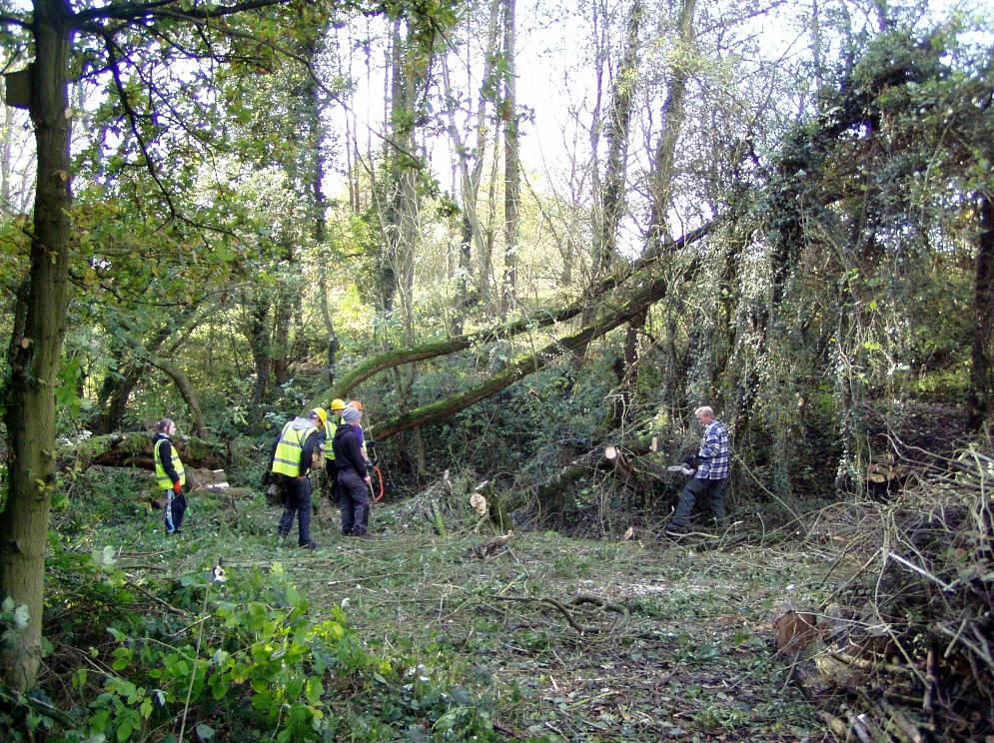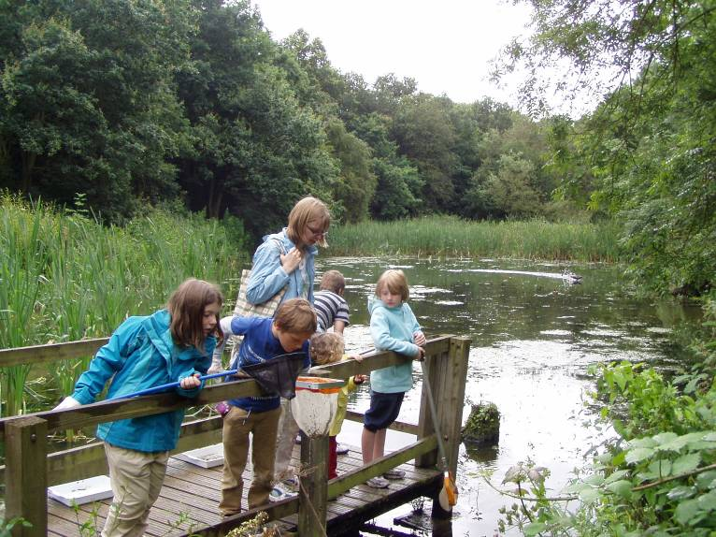**Meetings**

There has been two Friends Of Group meeting this quarter.

On Wednesday 18th July, six members turned up with apologies sent from three. Items discussed included the quotes received for the Red River leaflet, the new logo and the pond dipping platform project; we won the vote in the local Heanor Tesco, but are awaiting the final decision once the other stores votes are included. We are hopeful of achieving first place.

A Report was received from Alan, the Publicity Officer. We also discussed the plans for the next three task days on the 25th and the 15th and 31st August.

The second meeting was held on Wednesday 5th September. Again six people attended with apologies from three. The main topics were the Red River leaflet, the best quote was from Nottingham College via Kerry and Gary agreed to get the required changes made and forward a PDF version to Kerry to present to them. The main topic was the planning for the replacement pond dipping platform, as we have heard that we won the Tesco Bags of Help vote and have been awarded £4000. John agreed to produce a task specification and seek three quotes.

**Publicity**

**Publicity Officer**

Alan is continuing to promote the group, and the volunteering opportunities, in the local area. Posters and cards are regularly distributed to a number of local outlets including Heanor Library, the local Tesco Store and Shipley Country Park Visitor Centre. Two more new volunteers have recently attended the Saturday action days.

**Get Active! Help Nature Leaflet**

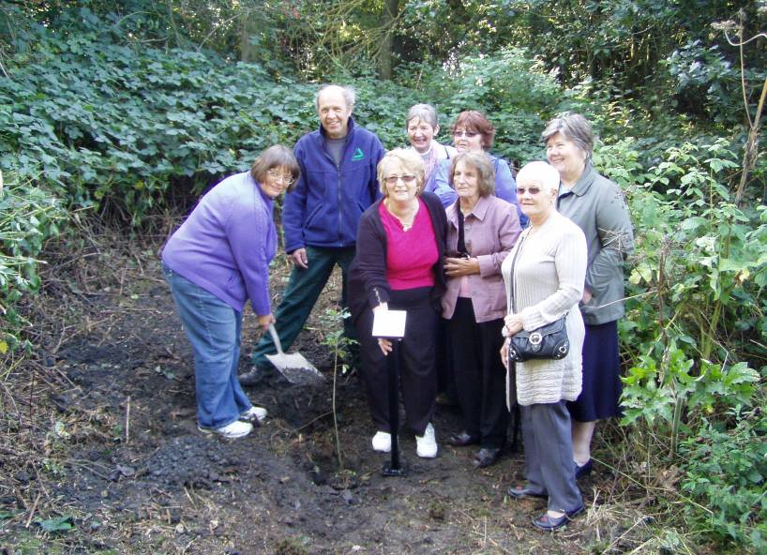The Nature Reserve continues to be publicised in the Groundwork general leaflet promoting the health benefits of volunteering in the local environment.

The leaflet is distributed to a number of local outlets and organisations including Amber Valley CVS. I am often contacted by potential conservation volunteers, some of whom attend the Red River FOG task days.

**Practical Task Programme**

All tasks and events at Red River LNR are promoted on my general task programme. The task programme is produced quarterly and distributed around all the Groundwork Conservation Volunteers working with me. It is also distributed to all members of the numerous Friends of Group who help on the other reserves, in Amber Valley and the Derbyshire Dales. The October to December programme has just been emailed and posted to all my volunteers.

**Tasks and Events**

Specific tasks and events are promoted by posters distributed locally, including the reserve notice board, the Tesco community board and the visitor centre at Shipley Country Park. We now have a poster specifically designed to promote the annual Christmas event.

**Site Leaflet**

I am currently working with members of the FOG to get the site leaflet updated and re-printed. A draft version has been produced and circulated to print companies to get quotes.

**Funding**

The group and I continue to seek out funding opportunities to support our work on the reserve.

A bid was submitted early this year to the Tesco Bags of Help scheme to secure funding to replace the Pond Dipping platform. The bid was selected nationally, to go forward to the public vote in the Derby area, which included the local Heanor store. It was voted on during May and June and we heard in August that we had been successful in winning the public vote, coming in first out of the three contenders. We have been awarded £4000 towards the Pond Dipping project.

*Groundwork is partnering Tesco in this Scheme and my role is to act as the community enabler for the Alfreton, Derby and Ilkeston areas. This means I promote and support bids within these Tesco areas, so I have to be one step removed from any bid submitted by the groups I assist.*

We are now considering funding sources to seek funding for materials to construct a small bridge over the stream linking the latest new wildflower glade to the main reserve path.

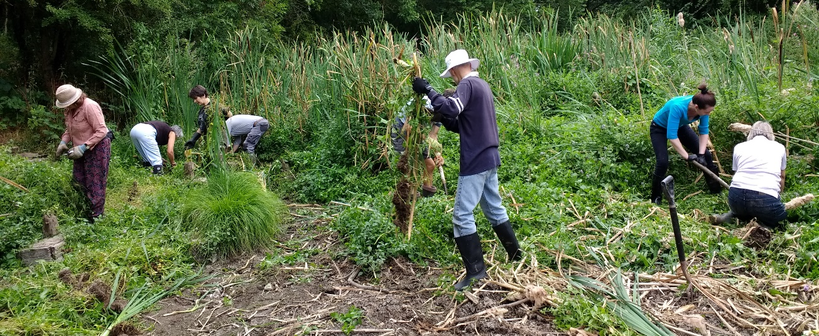

Reed pulling is a big job and requires a large team

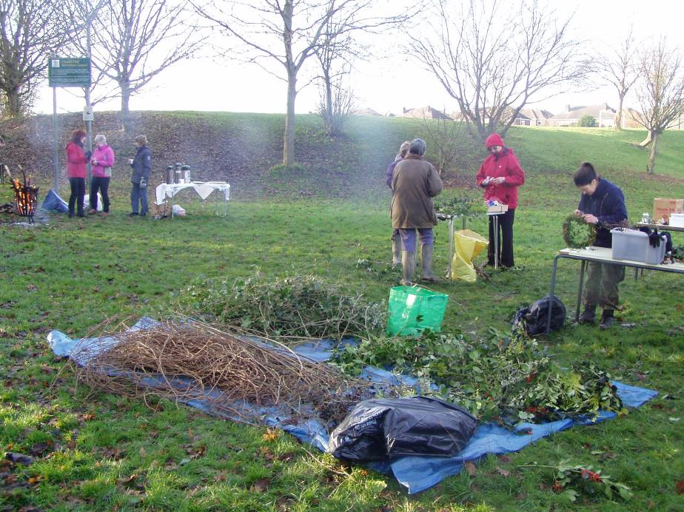**Statistics**

|  |  |
| --- | --- |
| P1010203**Summary Statistics - Quarter 2** |  |
| No. of individual volunteers on practical tasks | 15 |
| No. of individual volunteers on events | N/A |
| No. of individual volunteers on wildlife recording | 4 |
| No. of Friends of Group meetings/action days attended | 5 |
| No. of Practical volunteer days contributed by adult volunteers (171 hours divide by 6 hours) = 28.5 | 28.5 |
| No. of volunteer days contributed by volunteers on wildlife recording (15 hours divide by 6 hours) = 2.5 | 2.5 |
| No. of practical volunteer days contributed by young people | 0 |
| No of days on events contributed by volunteers | N/A |
| No. of adults attending events | N/A |
| No. of children attending events | N/A |
| No of activities/events/practical days delivered by GCAM | 7 |
| No of wildlife recording visits delivered by GCAM | 3 |
| No of additional days spent on site by extra Groundwork Staff | 1 |

|  |  |
| --- | --- |
| **Volunteer Information - Quarter 2** |  |
| Male volunteers | 8 |
| Female Volunteers | 7 |
| Unemployed | 4 |
| Employed | 6 |
| Retired | 5 |
| Students | 0 |
| Registered Disabled / Health problem | 4 |
| Under 18 | 0 |
| Aged 18-25 | 0 |
| Aged 26-40 | 4 |
| Aged 41-65 | 9 |
| Over 65 | 2 |

**Wildlife Recording**

I look and listen out for wildlife on all of my visits to the reserve, but often I am too involved with the practical tasks and supervising the volunteers to, systematically, record everything seen or heard.

I am continuing with the half-day wildlife recording visits to the reserve each month, to check and record our wildlife visitors and observe the changes in the flora.

I have spent two/three hours recording on the reserve each month this quarter; Thursday 26th July, Monday 13th August and Wednesday 26th September. I have been helped on these visits by three of our regular volunteers.

These monthly recording visits help to build up a picture of what is likely to be seen during the year, and gives a more comprehensive idea of what wildlife is around on the reserve. These types of records become more valuable over time and help to monitor changing and improving habitats on the reserve.

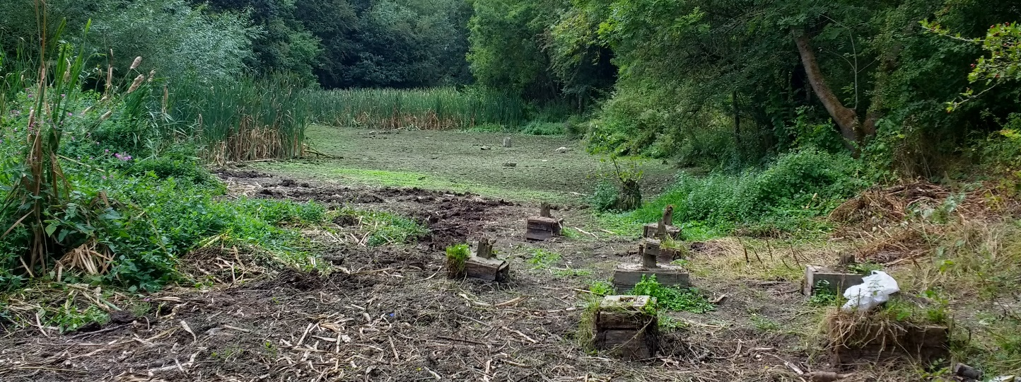

Red River’s pond dried out in the long, hot summer.

**Birds**

This quarter last year we spotted 32 different birds. This year we have spotted or heard a total of 31 species of bird.

* Bullfinch
* Goldfinch
* Buzzard
* Dunnock
* Grey Wagtail
* Pied Wagtail
* Sparrow Hawk
* Kestrel
* Wood Pigeon
* G. S. Woodpecker
* Green Woodpecker
* Song Thrush
* Blackbird
* Swift
* Swallow
* House Martin
* Crow
* Magpie
* Jay
* Starling
* Blackcap
* Chiff Chaff
* Nuthatch
* Tree Creeper
* Great Tit
* Blue Tit
* Long Tailed Tit
* Mallard
* Moorhen
* Robin
* Wren

**Butterflies**

Butterfly sightings between July and September have included; Peacock, Comma,Small White, Speckled Wood, Gatekeeper, Meadow Brown, Red Admiral, Small Skipper, Large White, Small Copper, Small Tortoiseshell and Ringlet.

**Monthly Records**

The month by month summary is shown below:

**July**

The wildlife recording visit and the task days were all towards the end of the month. Bird sighting highlights included Grey Wagtail along the stream and a Buzzard over the reserve on the 26th and Great Spotted Woodpecker and Green Woodpecker both heard on Wednesday 25th. Other July bird records included Bullfinch, Pied Wagtail and Long Tailed Tit. Summer visitors seen or heard were Chiff Chaff, Blackcap, Swallow and House Martin. There were sightings of both Dragonfly and Damselfly but these were not identified as to type.

Meadow Brown and Ringlet were the most prolific butterflies spotted in the in the wildflower meadows. Other butterfly sightings included Small Copper and Small skipper. Flowering plants included Tufted Vetch, Field Scabious, Meadow Cranesbill, Meadow buttercup, Red Clover and Ox Eye Daisy.

**August**

This was a great month for butterflies with nine different species seen; the highlights being Small Copper, Comma and Gatekeeper.

Three species of bird of prey were seen in August, Buzzard, Kestrel and Sparrow Hawk. On the pond the Moorhens and Mallards had chicks. The highlight of the month was again Grey Wagtail, two this time in the stream bed and a Song thrush is also worthy of a mention. Other notable birds seen in August were Swift, Nuthatch and Blackcap.

Plants in flower included Meadow Sweet, Purple Loosestrife, Red Campion, Greater Willow Herb, Marsh Woundwort and Birds Foot Trefoil and Self Heal in the meadow.

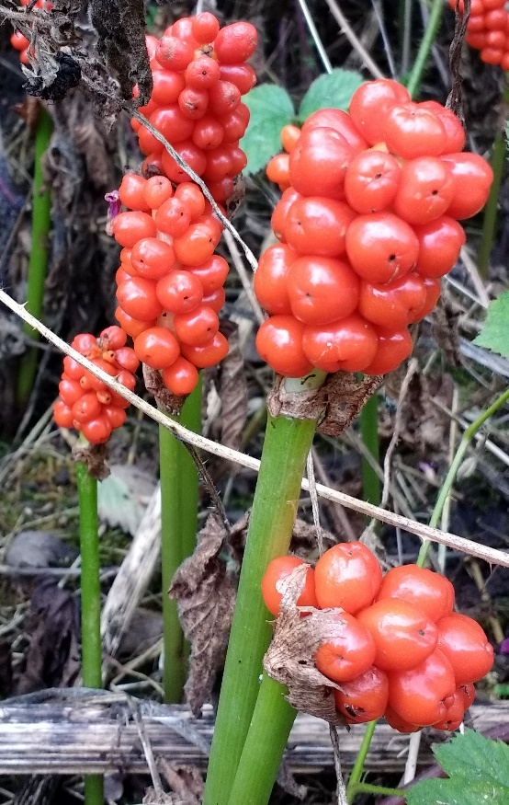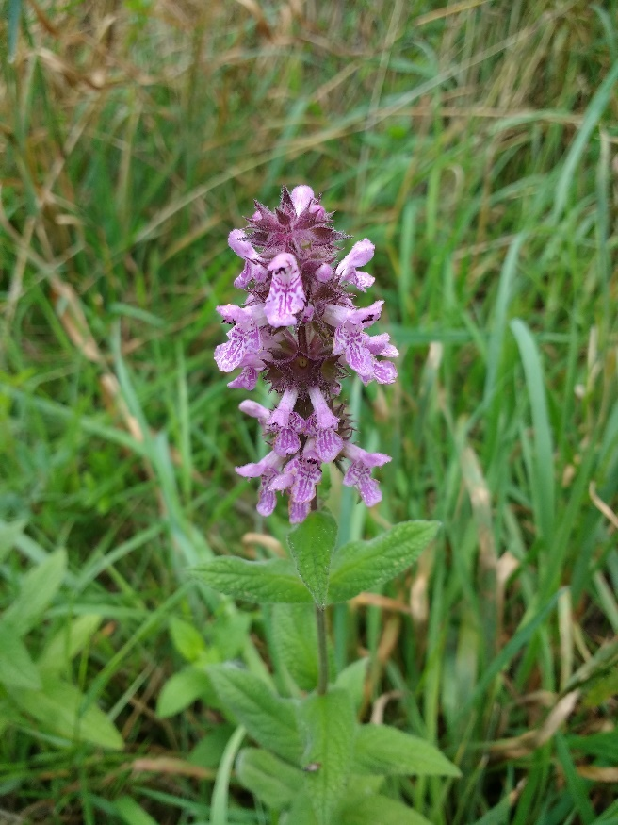

Marsh Woundwort

Lords and Ladies

**September**

Most birds had already stopped singing, but the Chiff Chaff, (the sound of Summer) was still regularly heard throughout September. Both Swallow and House Martin were still being spotted but are likely to be leaving for Africa soon. Bullfinch and Goldfinch are the two most regularly seen finches, a big change over the last few years.

Late butterfly sightings included Speckled Wood, Small White and Small Copper.

A lot of the flowers have now stopped flowering and all the meadows were mown during August but plants still in flower included Red Campion, Meadow Buttercup and Water Mint. Lords and Ladies had wonderful bright red seed heads on show.

It is a good year for berries and the Hawthorn, Wild Rose, Bramble and Rowan, have wonderful displays of colourful berries. These will be really useful for the birds during autumn and winter.

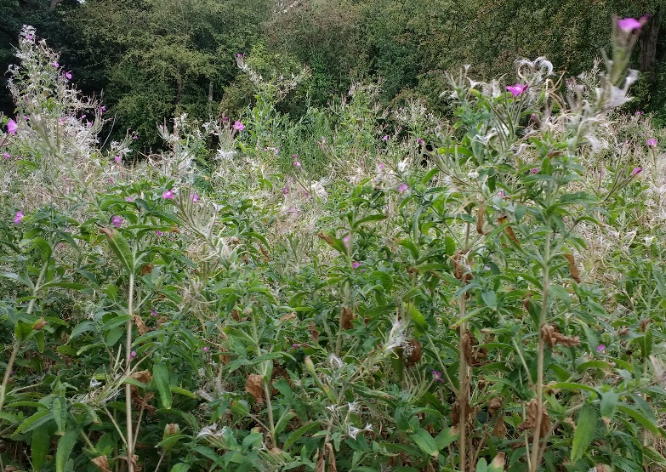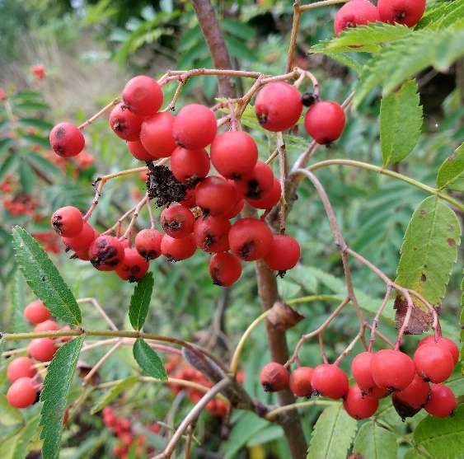

Greater Willow Herb

Rowan Berries

**Future Tasks**

During Quarter 3 (October to December 2018) the following meetings/practical days/events/activities are planned (please check with me before attending, as these dates may change):-

Wednesday 3rd October Wildlife Recording Visit

Saturday 13th October FOG Action Day

Monday 15th October Conservation Volunteers Task Day

Wednesday 7th November FOG Meeting

Saturday 10th November FOG Action Day

Monday 12th November Conservation Volunteers Task Day

Tuesday 13th November Wildlife Recording Visit

Saturday 8th December (am) FOG Action Day

Saturday 8th December (pm) Christmas Event

Monday 10th December Conservation Volunteers Task Day

Friday 14th December Wildlife Recording Visit